**GUVI ZEN FINAL PROJECT - 1**

**POWER BI DASHBOARD KPI’S**

NAME: **ASTER NATHAN**

BATCH: **DM3**

**CONTENTS**

1. INTRODUCTION
   1. Power BI
   2. Sales Data
   3. KPI (Key Performance Indicator’s)
2. INSIGHTS ON THE KPI’s OF THE DATA VISUALIZED AND ANALYSED
   1. Region wise analysis
   2. Customer wise analysis
   3. Age wise analysis
   4. Gender wise analysis
   5. Order status analysis
   6. Product wise analysis
   7. Product trend analysis
   8. Payment method analysis
   9. Weekend Vs. Weekday analysis

**INTRODUCTION:**

**Power BI:**

Power BI is a business intelligence and data visualization tool developed by Microsoft. It allows users to connect to a wide range of data sources, including spreadsheets, databases, and cloud services, and create interactive dashboards, reports, and data visualizations.

Power BI has a user-friendly interface that makes it easy to create compelling visualizations with drag-and-drop functionality. Users can also write custom calculations and measures using a powerful formula language called DAX.

Power BI also includes features for data modeling, data transformation, and data cleansing, which makes it a powerful tool for data preparation. Additionally, Power BI can be integrated with other Microsoft tools like Excel and SharePoint, as well as other third-party applications.

**Sales Data:**

Sales data refers to information about the sales of a particular product or service. It typically includes details such as the number of units sold, the revenue generated, and the profit margin.

Sales data can be collected and analyzed to gain insights into a company’s performance, identify trends, and make informed decisions about pricing, marketing, and product development.

**KPI (Key Performance Indicator):**

KPI stands for Key Performance Indicator. It is a measurable value that organizations use to track and evaluate their progress towards achieving specific business objectives. KPIs can be applied to various areas of an organization, including sales, marketing, customer service, finance, and operations.

KPIs are important because they provide a way to measure success and identify areas where improvements are needed. By setting specific KPIs, organizations can establish clear goals and targets, and monitor progress towards achieving them. KPIs can be both quantitative (e.g., revenue growth, customer retention rate) and qualitative (e.g., customer satisfaction, employee engagement).

**INSIGHTS ON THE KPI’s OF THE DATA VISUALIZED AND ANALYSED**

1. **Region - Wise Analysis:**

Region-wise analysis in a sales dataset involves examining the sales data and performance metrics by region, which can help organizations, understand how their products or services are performing in different regions. This analysis can provide valuable insights into customer behaviour, market trends, and performance drivers, which can help organizations optimize their sales strategies and improve profitability.

Region-wise analysis can help organizations identify areas where they are performing well and areas where they need to improve. It can also help them identify opportunities for growth and expansion, as well as risks and challenges associated with operating in specific regions. By leveraging region-wise analysis, organizations can make data-driven decisions and optimize their sales strategies to maximize profitability.

The dataset provided was divided into 4 different regions namely Midwest, Northeast, South and West.

1. Sum of Total by Region:

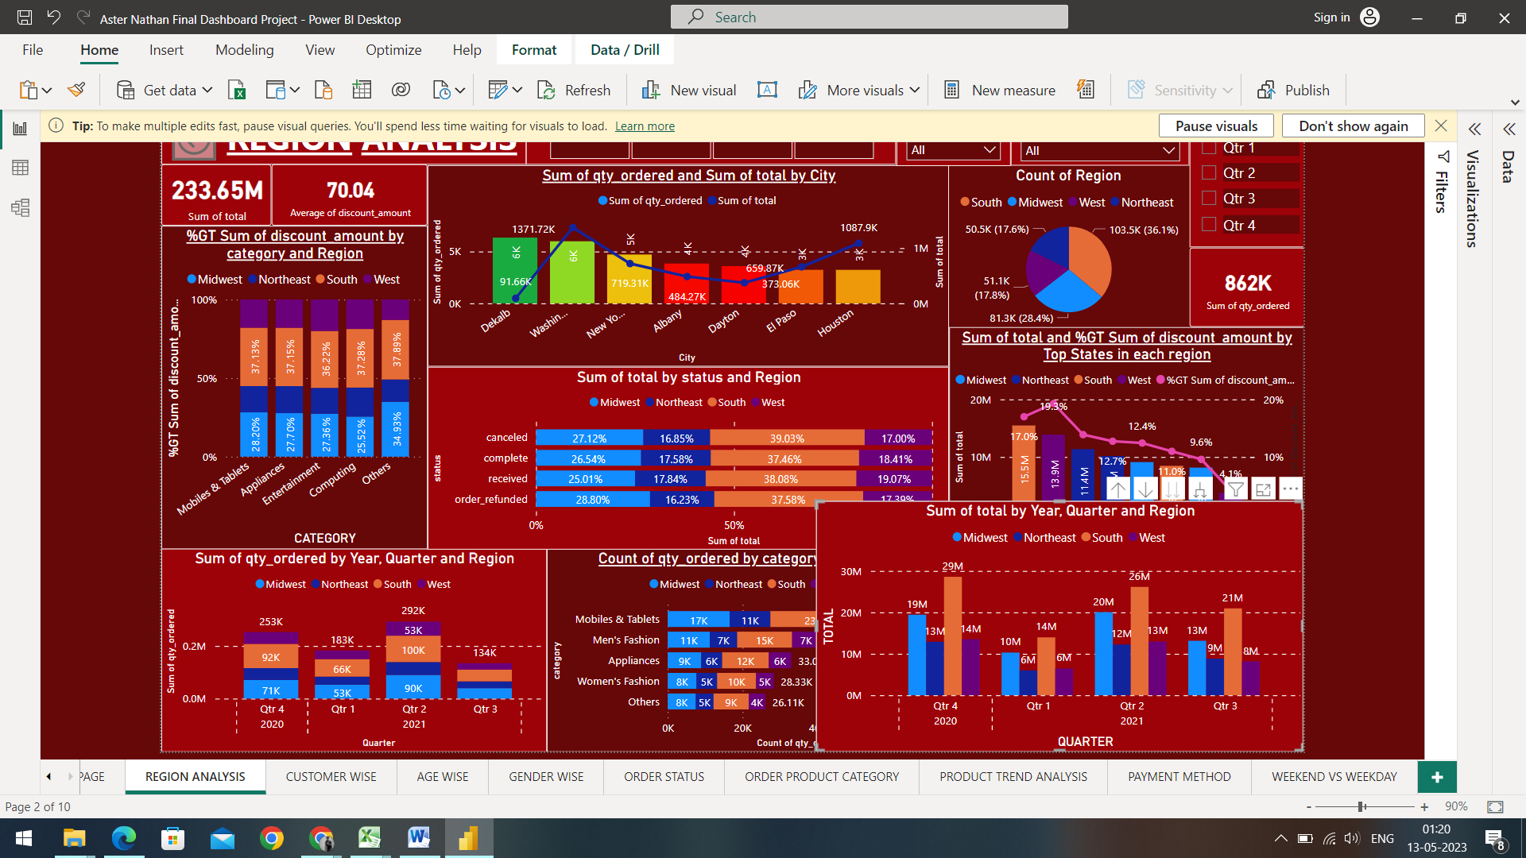

The graph above displays the total sales and profit by region and the Quarters of the year 2021 and the 4th Quarter of the year 2020.

* The 4th Quarter of 2020 gives us an insight that the most amount of Total was driven by the South region with 29 Million. The second most sales driven by any region is the Midwest region with 19 Million, followed by the West region with 14 Million and then, by the Northeast region with 13 Million total Sales.
* The 1st Quarter of 2021 drove the least amount of total among the other Quarters and also gives us an insight that the most amount of Total was driven by the South region with 14 Million. The second most sales driven by any region is the Midwest region with 10 Million, followed by the West region and Northeast region with the same amount of Sales with 6 Million total Sales.
* The 2nd Quarter of 2021 gives us an insight that the most amount of Total was driven by the South region with 26 Million. The second most sales driven by any region is the Midwest region with 20 Million, followed by the West region with 13 Million and then, by the Northeast region with 12 Million total Sales.
* The 3rd Quarter of 2021 gives us an insight that the most amount of Total was driven by the South region with 21 Million. The second most sales driven by any region is the Midwest region with 13 Million, followed by the Northeast region with 9 Million and then, by the West region with 8 Million total Sales.

Root Cause Analysis and Key Driving Factors:

We can see a low amount of sales trends in the Northeast, West and Midwest region as compared to the best performing South region, to improve this and to increase the sales of the underperforming regions, we can perform target based marketing and create targeted marketing campaigns that are specifically designed to appeal to customers in such underperforming regions. By highlighting the unique features or benefits of our products or services that are most relevant to customers in these regions, businesses can increase their appeal and drive sales.

1. Category wise Sales by Region:

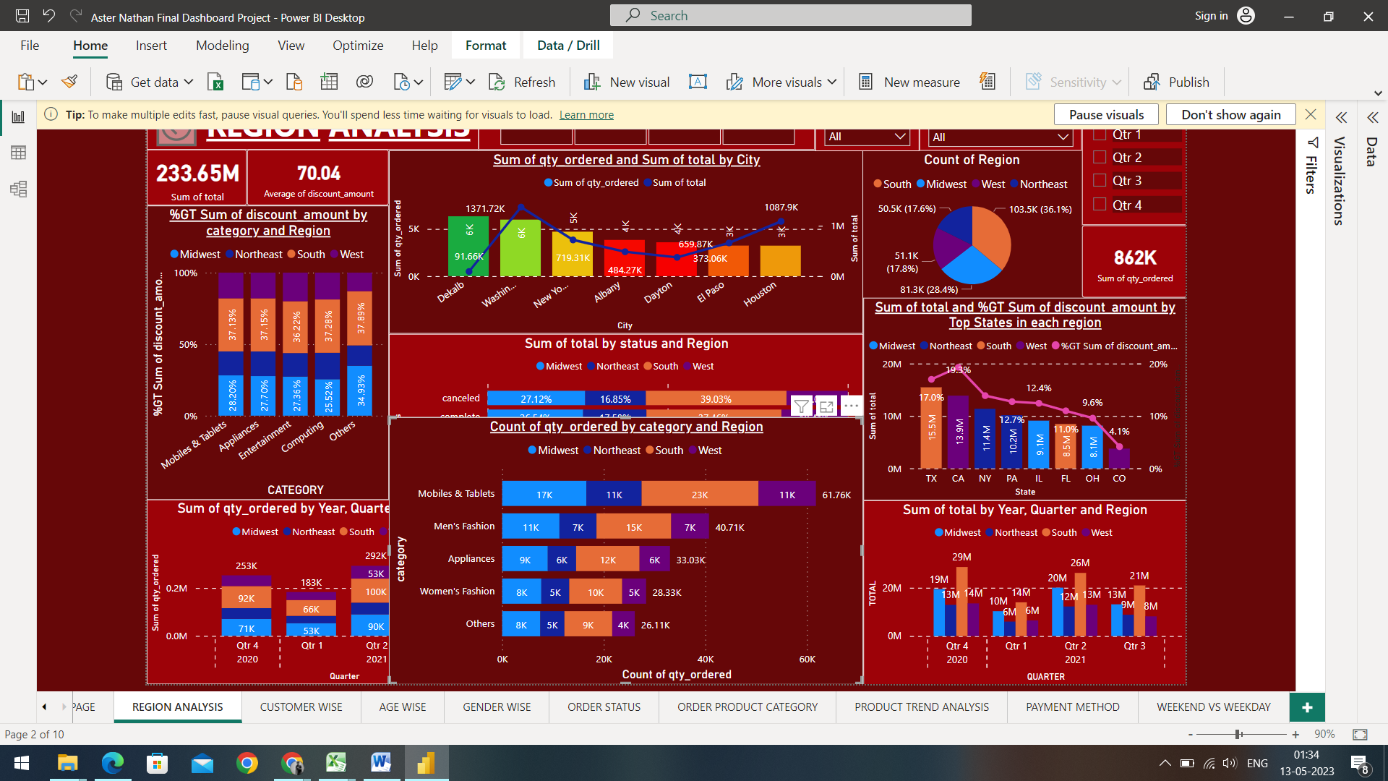

The top 5 performing categories are:

Mobiles & Tablets with a total count of Quantity of 61.76K, Men’s Fashion with a total count of Quantity of 40.71K, Appliances with a total count of Quantity of 33.03K,

Women’s Fashion with a total count of Quantity of 28.33K and Other Categories with a total count of Quantity of 26.11K.

* Mobiles & Tablets:
* The most amount of Quantity ordered was from the South region with 23K Quantities ordered
* The Second most amount of Quantity ordered was from the Midwest region with 17K Quantities ordered.
* The Northeast region and West region ordered the same amount of Quantities with 11K Quantities ordered.
* Men’s Fashion:
* The most amount of Quantity ordered was from the South region with 15K Quantities ordered
* The Second most amount of Quantity ordered was from the Midwest region with 11K Quantities ordered.
* The Northeast region and West region ordered the same amount of Quantities with 7K Quantities ordered.
* Appliances:
* The most amount of Quantity ordered was from the South region with 12K Quantities ordered
* The Second most amount of Quantity ordered was from the Midwest region with 9K Quantities ordered.
* The Northeast region and West region again ordered the same amount of Quantities with 6K Quantities ordered.
* Women’s Fashion:
* The most amount of Quantity ordered was from the South region with 10K Quantities ordered
* The Second most amount of Quantity ordered was from the Midwest region with 8K Quantities ordered.
* The Northeast region and West region ordered the same amount of Quantities with 5K Quantities ordered.
* Others:
* The most amount of Quantity ordered was from the South region with 9K Quantities ordered
* The Second most amount of Quantity ordered was from the Midwest region with 8K Quantities ordered.
* The Northeast region ordered the third most amount of Quantities with 5K Quantities ordered.
* The West region ordered the least amount of Quantity with 4K Quantities ordered.

Root Cause Analysis

We can see a trend based on different product categories in reference to the preference of customers in the different regions. As Mobile and Tablets have a much profit margin compared to any other product category, we can encourage customers to purchase additional items from the well-performing category through upselling and cross-selling techniques can also help to drive more sales.

Offering discounts is another method on products from the well-performing category can help to encourage customers to make purchases. This could involve offering a limited-time discount on the products to encourage more sales.

1. Sum of Total by Status and Region:

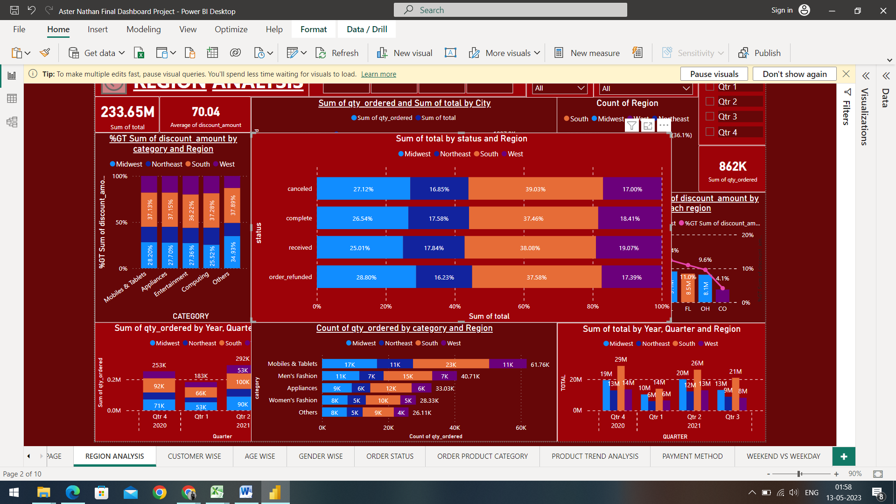

Order status refers to the current state or stage of an order, typically in the context of a customer order or purchase. The order status can provide important information to both the customer and the seller, such as whether the order has been received, processed, shipped, or delivered.

* Cancelled Orders:
* Out of the Total 100% of the Order Status, 39.03% of the orders in the South region contributed to the most amounts of cancellations.
* In the Midwest region, the Cancellation of Orders stood at 27.12%, contributing to the second most amounts of Cancellations.
* The third most cancelled orders belonged to the West region at 17.00%.
* The least amount of Cancellations stood at 16.85% in the Northeast region.
* Complete Orders:
* Out of the Total 100% of the Order Status, 37.46% of the orders in the South region contributed to the most completed orders.
* In the Midwest region, the Completed Orders stood at 26.54%, contributing to the second most amounts of Completions.
* The third most Completed orders belonged to the West region at 18.41%.
* The least amount of Completed orders stood at 17.58% in the Northeast region.
* Received Orders:
* The most orders received status belonged to the South region with 38.08% of Orders being received by the customers.
* The second most orders received by customers belonged to the Midwest region with 25.01% Orders.
* The third most orders received status belonged to the West region with 19.07% of the Orders being received.
* The Northeast region accounted to the least amount of orders received with 17.84% of the Customers received their orders.
* Refunded Orders:
* The most amount of Refunded orders belonged to the South region with 37.58% of the orders being refunded for the customers.
* The second most amount of Refunded orders belonged to the Midwest region with almost 29% of the orders being refunded by the customers.
* The third most refunded orders belonged to the West region with 17.39% of the total orders being refunded.
* The least amount of refunded orders belonged to the Northeast region with 16.23% of the total orders being refunded by the Customers.

Root Cause Analysis:

We can see a trend of Cancelled orders was a lot compared to the completed orders. In order to improvise this trend, we can monitor customer feedback and respond promptly to concerns or complaints. This will help to build trust with customers and reduce the likelihood of cancellations due to unresolved issues. We can Track and analyse cancellation patterns to identify common causes and areas for improvement. This will help to inform future efforts to reduce cancellations.

1. Sum of Total and Percentage of Discount by Top States:

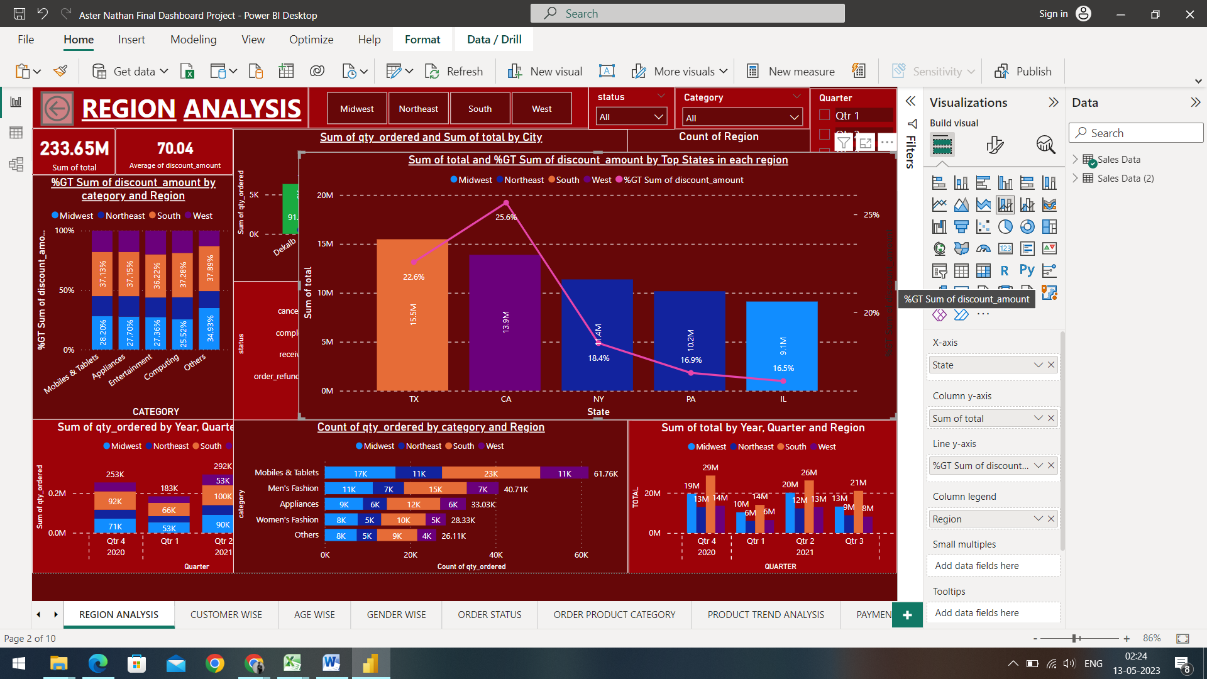

The top five performing States by the sum of Sales are:

* Texas:
* Texas drove the most amounts of sales with 15.5 Million sales and the percentage of the total discount stood at 22.6%.
* California:
* California stood second, driving around 13.9 Million sales and the percentage of the total discount was the most compared to any other region with 25.6%
* New York:
* The state of New York drove the third most amount of sales with 11.4 Million sales and the total discount stood at 18.4%
* Pennsylvania:
* Pennsylvania stood at 4th most profitable state with 10.2 Million sales and the total discount stood at 16.9%.
* Illinois:
* The state of Illinois drove the fifth most amounts of sales with 9.1 Million sales and the total discount stood at 16.5%.

Key driving factors:

As you can see, the amount of discount given is more or less inter related to each other as the top states were given massive amounts of discounts and the states that were given moderate to low discounts did not contribute to the level of the top states.

1. Sum of Total and Sum of Quantity ordered by Top 10 Cities:

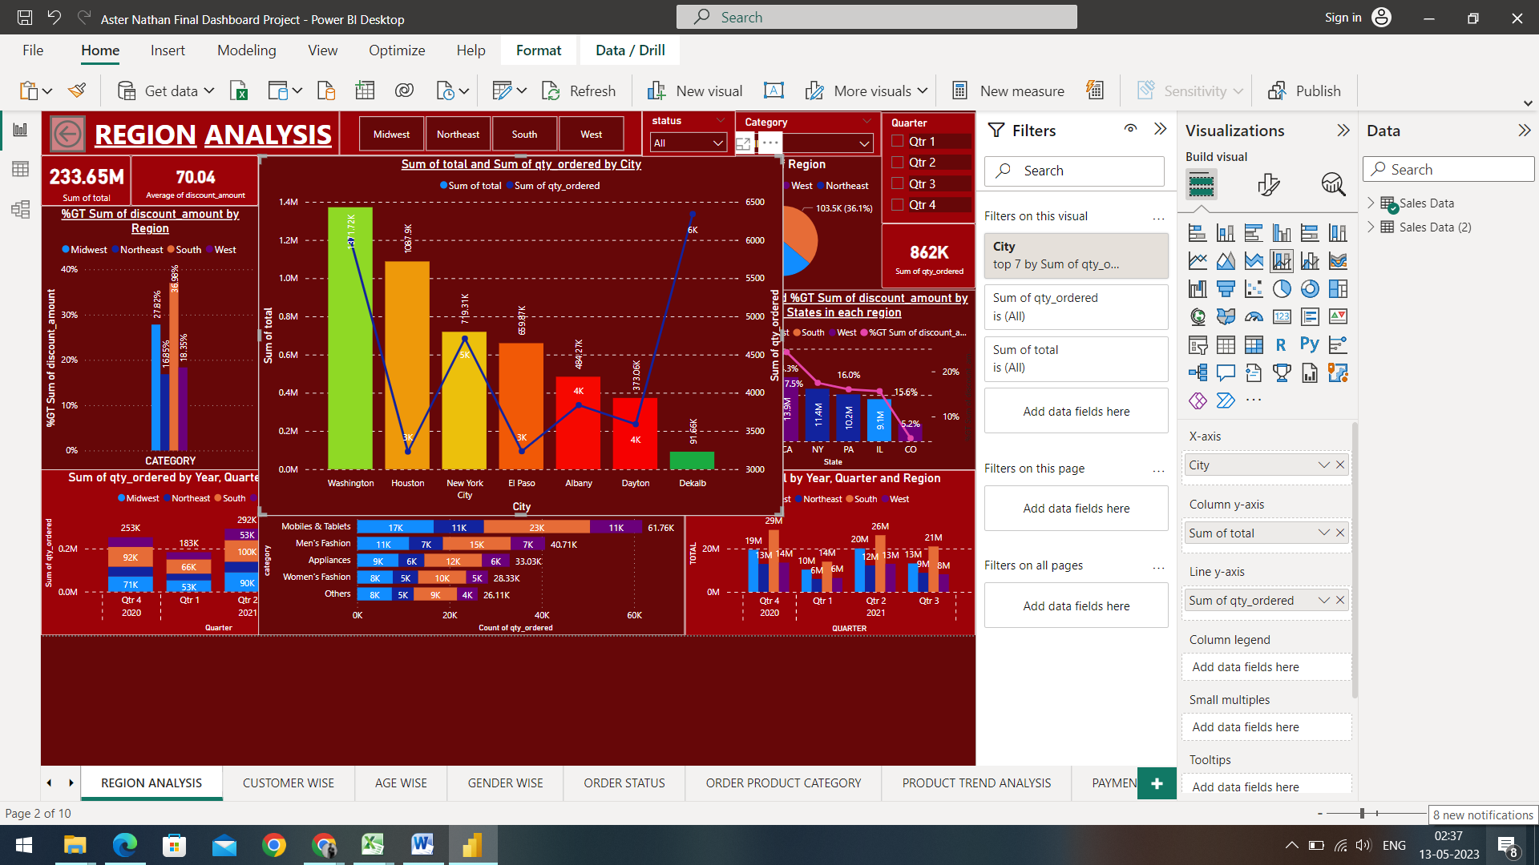

In the graph above, the columns represent the Sum of total by Top 7 cities and the Line represents the Sum of Quantity.

The top 7 cities by Sum of total are as follows:

* Washington:
* The city of Washington contributed to the most amounts of Sales with 1371.72K total Sales and the Sum of Quantity stood at 5.9K.
* Houston:
* The second most cities contributing to the total sales belongs to the City of Houston with 1087.9K total Sales and the Sum of Quantity stood at just 3K.
* New York City:
* New York City stood in the third position as it contributed with 719.31K total Sales and the Sum of Quantity stood at 5K
* El Paso:
* El Paso contributed with 669.87K total Sales and the Sum of Quantity stood at 3.2K
* Albany:
* Albany stood fifth in terms of the most contributed Sales with 484.2K total Sales and the Sum of Quantity stood at 4K
* Dayton:
* The city of Dayton contributed with 303.6K total Sales and the Sum of quantity stood at 3.5K
* DeKalb:
* The city of DeKalb stood as the seventh most contributed city with the total sales of 91.66K, however it drove the most sum of Quantity with 6K Quantities.

Key Driving Factors:

As observed from the pattern above, we can see that the top cities are making a huge amount of sales, but the quantity of products they ordered are not inter-related, this could be because the customers in those cities prefer products that are luxurious/monetary products and in order to increase the sales more, we can execute target based analysis on such customers and collecting their data and suggest them about the similar products that will go hand-in-hand based on their previous purchases.

1. Percentage of the Sum of Discount by Region:

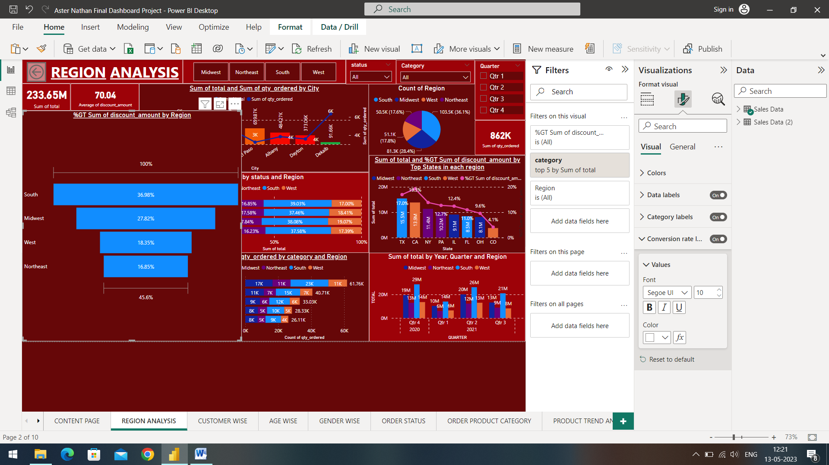

A discount is a reduction in the price of a product or service that is offered to a customer. Discounts are typically given as a promotional tool to increase sales or to encourage customer loyalty. Discounts can be given in a variety of ways, including percentage discounts, fixed amount discounts, buy-one-get-one-free deals, or free shipping.

The Sum of discount percentage by region are as follows:

* South:
* The south region was given the most amount of discount with approximately 37% of the discount compared to other regions.
* Midwest:
* The Midwest region was given the second most sum of discount with 27.82% of the discount
* West:
* The West region was given just 18.35% of the total discount sum, which is way lower compared to the other two top regions.
* Northeast:
* The Northeast region was given the least amount of discount with just 16.85%.

Root Cause Analysis:

As we can observe, the South region is being given a greater amount of discount compared to the other regions and that is driving more sales in the specific area, in order to improve this pattern of discounts, we need to understand the customer behaviour in the underperforming regions and can offer targeted or volume discounts to customers who purchase larger quantities of your products or services. This can encourage customers in underperforming regions to buy more, and help boost our sales. Implementing a loyalty program that rewards customers for repeat purchases. This can encourage customers in underperforming regions to continue shopping with you and help build a loyal customer base. We can also consider matching or beating the prices of our competitors in underperforming regions. This can help us remain competitive and attract more customers to your business.

1. Sum of Quantity ordered by Region and Year, Quarter:

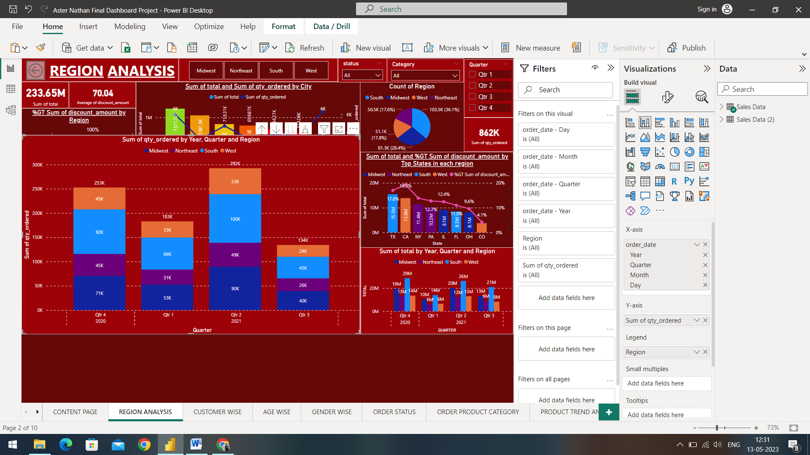

The graph above displays the Sum of Quantity by region and the Quarters of the year 2021 and the 4th Quarter of the year 2020.

* The 4th Quarter of 2020 gives us an insight that the total amount of Quantities ordered was 253K, out of which, the most amount of quantities were ordered by the South region with 92K. The second most quantities ordered were driven by any region is the Midwest region with 71K, followed by the West region and the Northeast region with exactly the same amount of quantities ordered with 45K quantities ordered.
* The 1st Quarter of 2021 drove a total of 183K Quantities ordered and also gives us an insight that the most amount of Quantities were ordered by the South region with 66K. The second most Quantities ordered by any region is the Midwest region with 53K, followed by the West region with 33K Quantities and then by the Northeast region with 31K Quantities ordered.
* The 2nd Quarter of 2021 drove the most amount of total quantities bought with 292K Quantities bought and also gives us an insight that the most amount of Quantities were bought by the South region with 100K. The second most Quantities ordered by any region is the Midwest region with 90K, followed by the West region with 53K and then, by the Northeast region with 49K.
* The 3rd Quarter of 2021 drove the least amount of total compared to other region with the sum of quantities ordered was just 134K and also gives us an insight that the most amount of Total was driven by the South region with 45K. The second most Quantities ordered by any region is the Midwest region with 40K, followed by the Northeast region with 26K and then, by the West region with 24K sum of quantities ordered.

Root Cause Analysis:

To improve the sales of the regions over time, we can implement a strategic approach that takes into consideration the unique characteristics of the region and business. We can develop a deep understanding of the customers in the region by conducting market research, analysing sales data, and listening to customer feedback. Also expanding our product line to meet the changing needs of customers in the region. Conduct market research to identify new product opportunities and develop a product launch plan that includes promotional campaigns and pricing strategies. Developing strong relationships with customers, suppliers, and partners in the region.

1. **Customer Analysis:**

Customer analysis is the process of gathering and analysing data on customer behaviour, preferences, and demographics to gain insights into their needs and preferences. It involves collecting and interpreting data on factors such as customer demographics, purchase history, website usage, feedback and social media activity. The goal of customer analysis is to better understand customer needs and preferences, improve the customer experience, and increase customer loyalty and retention.

1. Sum of Total by Customer Name and Region:

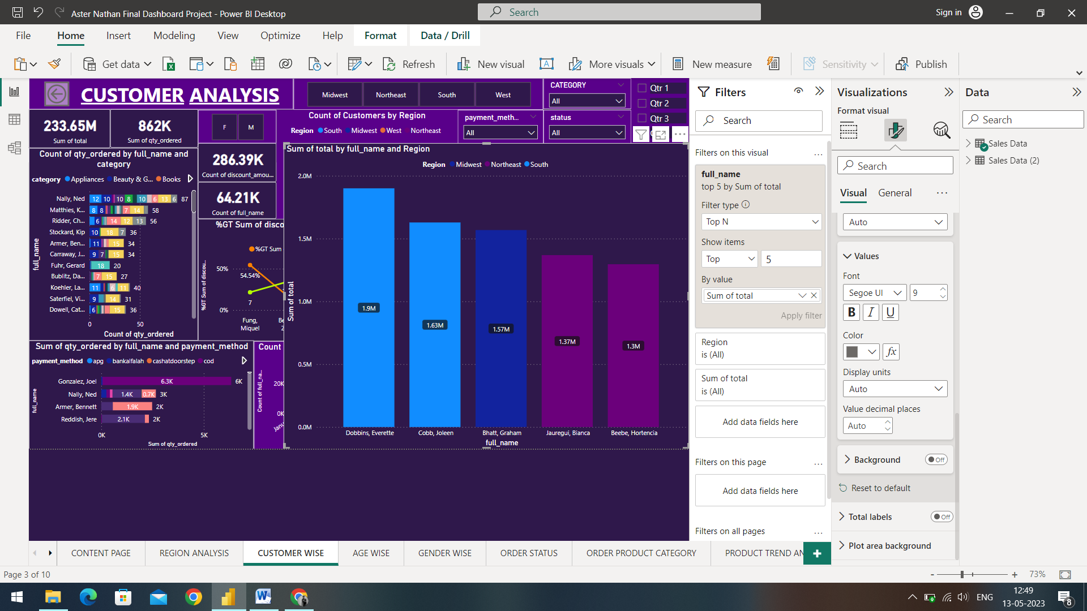

* The most amount of Sales were driven by the customer Everette Dobbins who belonged to the South region with approximately 2 Million of total Sales driven.
* The second most Total was driven by the customer Joleen Cobb belonging to the South region with around 1.63 Million Total sales driven.
* The third most sales were driven by the customer Graham Bhatt residing in the Midwest region with 1.57 Million total sales driven.
* The fourth most sales were driven by the customer Bianca Jauregui in the Northeast region with 1.37 Million of total sales driven
* The fifth most monetary customer who drove the most amount of total was Hortencia Beebe belonging to the Northeast region with 1.3 Million of Total Sales driven.

Root cause Analysis:

We can improve customer experience in order to increase the growth of customers; in order to achieve this, we can conduct research to understand customer needs and preferences. This can include analysing customer feedback, conducting surveys, and monitoring customer behaviour. We can also ensure that customer service is responsive, friendly, and helpful. Using customer data to personalize the experience and make recommendations based on past purchases and preferences. Providing support after the purchase is complete to ensure that customers are satisfied with their purchase.

1. Sum of Quantity ordered and the preferred payment method:

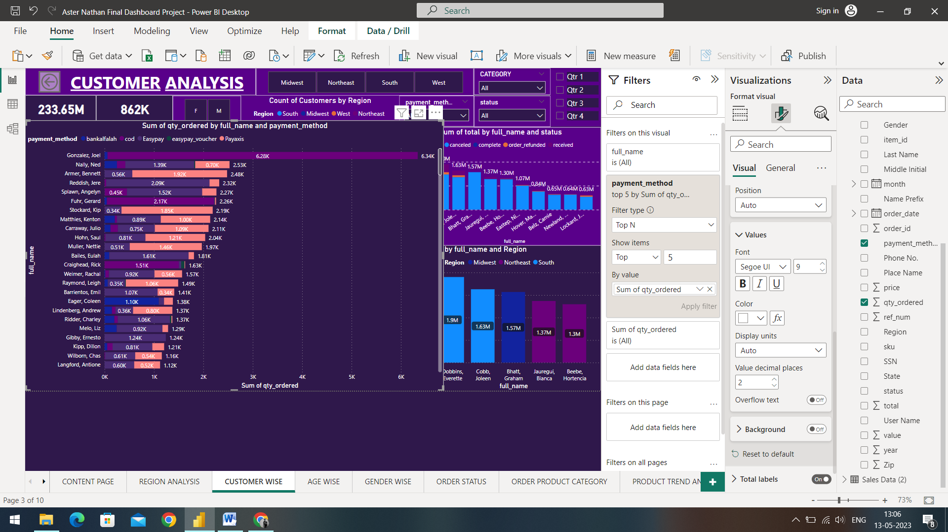

Analysing customer preferred payment methods involves gathering and analysing data on the payment methods that customers use most frequently. This information can be used to optimize payment processing systems, improve the checkout experience, and increase customer satisfaction.

* The most amount of quantities were ordered by the customer Joel Gonzalez with a massive 6.34K quantities ordered and the preferred mode of payment was cod (cash on delivery) with 6.28K and the remaining amount being preferred by the bankalfalah mode of payment.
* The second most quantities were ordered by the customer Ned Nally with 2.53K of total quantities ordered out of which the majority of the mode of payment preferred was the Easypay payment method followed by Payaxis.
* The third most quantities were ordered by the customer Bennett Armer with around 2.48K total quantities ordered and the most of it being paid by Payaxis followed by the Easypay mode of payment.
* The fourth most quantities were ordered by the customer Jere Reddish with 2.32K ordered quantities, out of which the most preferred mode of payment was Easypay.
* The fifth most quantities were ordered by the customer Angelyn Spawn with 2.27K and the most preferred mode of payment was Easypay with 1.52K followed by cod(cash on delivery) with 0.45K orders paid.

Root Cause Analysis:

Promoting preferred payment methods is essential to make the payment process easier for customers. Displaying logos of preferred payment methods prominently on your website, social media, or in-store can help customers identify which payment methods you accept and encourage them to use them. Communicating the benefits of using preferred payment methods to customers. Analyse payment trends to determine which payment methods are preferred by your customers. Use this data to refine your payment options and tailor your promotions and incentives to better meet customer needs.

1. Count of Distinct Quantities ordered by Customers and category of products:

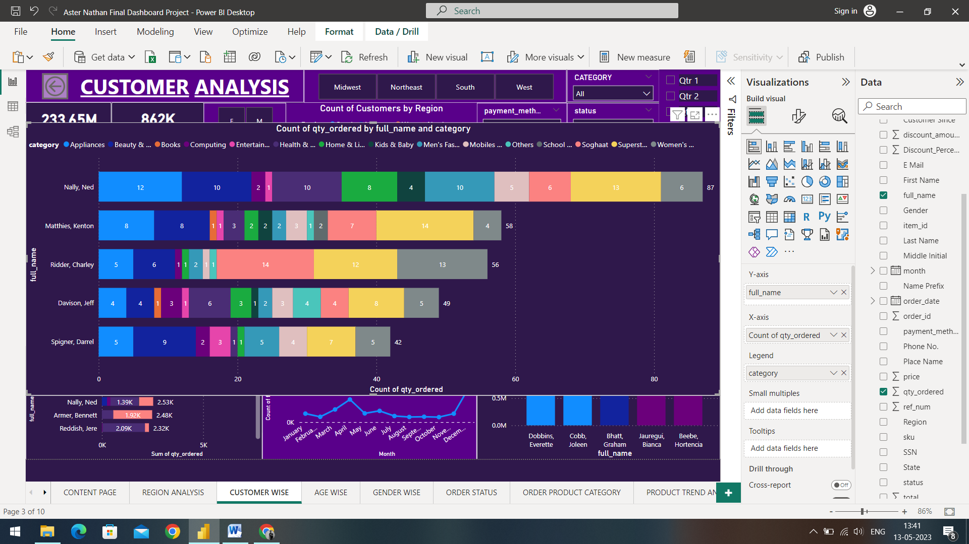

The distinct quantities of product categories refer to the different categories and quantities of products ordered by the customers.

* The most distinct product quantities were bought by the customer named Nally Ned with 87 distinct products bought, and the categories that contributed the most are; Superstore products with 13 quantities and Appliances with 12 quantities.
* The second most customer who bought the most amount of distinct product quantities is Kenton Matthies who bought 58 distinct quantities and out of which, Superstore contributing to 14 different.
* The customer Charley Ridder stood third with 56 distinct quantities of product and the categories that contributed the most are Soghaat with 14 quantities and School & Education with 13 quantities.
* The fourth most distinct product quantities were bought by the customer Jeff Davison with 49 distinct products bought and the categories that contributed are Superstore with 8 quantities and Health & Sports with 6 quantities of products.
* The fifth most distinct product quantities were bought by the customer Darrel Spigner with 42 distinct products bought and the categories that contributed are Beauty & Grooming products with 9 quantities of products and the Superstore products with 7 quantities of products.

Root Cause Analysis:

To boost sales of underperforming products, we can analyse our sales data to identify the root cause of underperformance in a particular product category. Is it due to a lack of demand or an issue with pricing, or promotion? Once we understand the root cause, you can develop a plan to address it. Offer promotions and discounts on products in the underperforming category to incentivize customers to try them out. Using cross-selling and up-selling techniques to encourage customers to purchase more products from the underperforming category. Educating customers about the benefits and uses of the products in the underperforming category.

1. Count of Distinct Customers by Months:

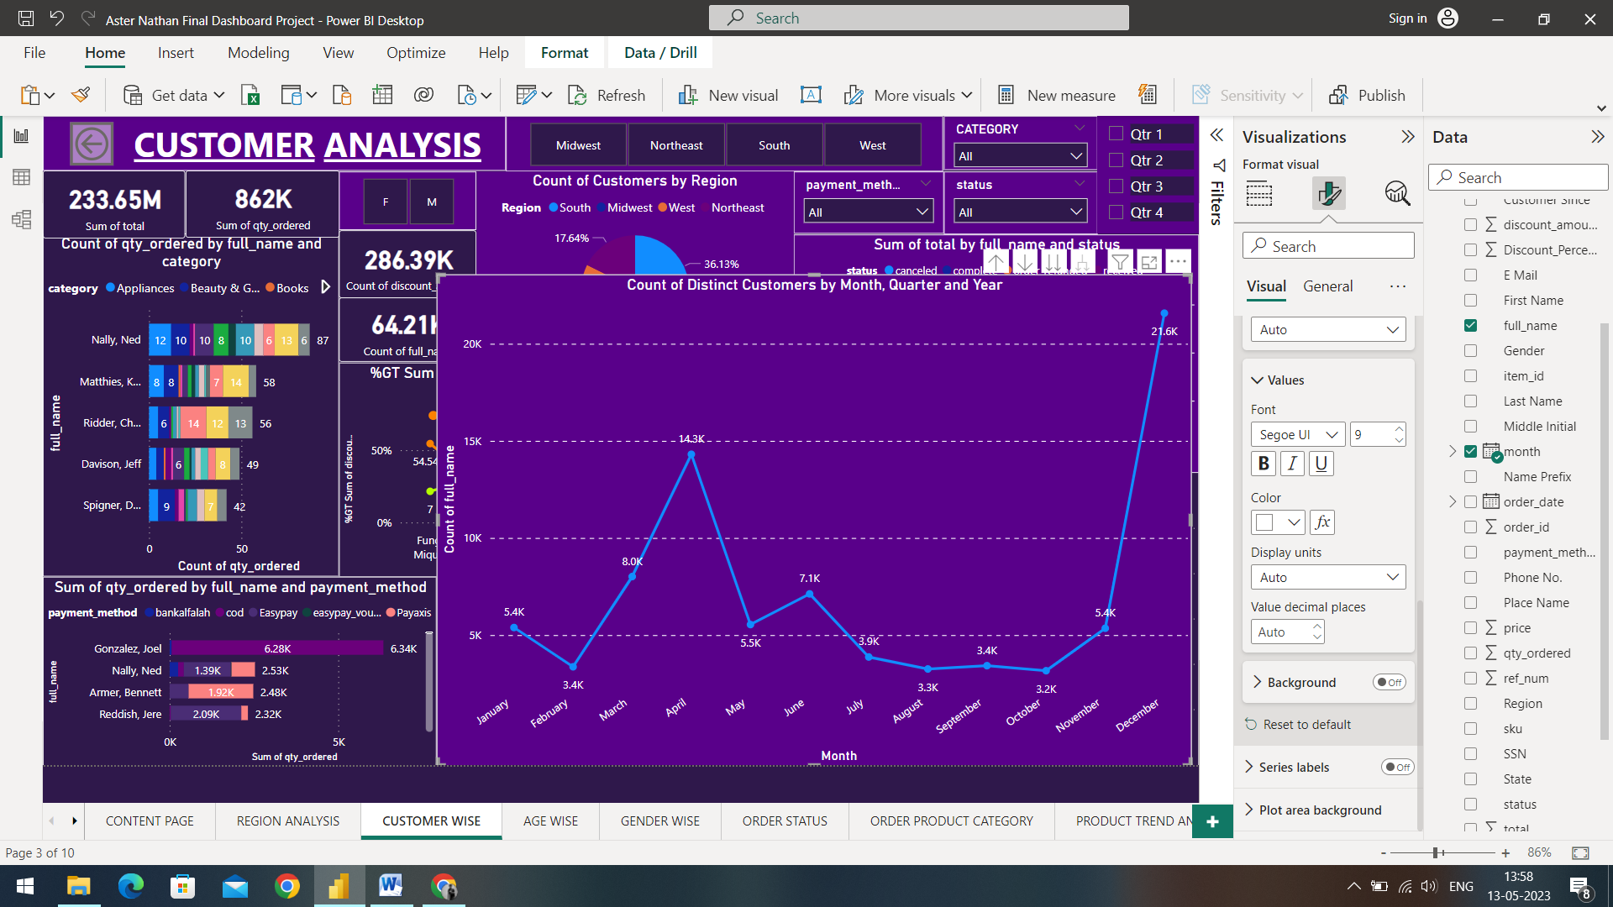

Count of Distinct customers helps us gain an insight on the Customer growth and refers to the expansion of a business's customer base over time. It is an important metric for measuring the success of a business, as it is a key driver of revenue and profitability.

* January:
* The Count of New customers in the month of January was 5.4K
* February:
* The Count of New customers in the month of February was reduced down to 3.4K
* March:
* The count of New customers in the month of March increased to 8.0K
* April:
* The count of New customers in the month of April skyrocketed to 14.3K
* May:
* The Count of New customers in the month of May was reduced down to 5.5K
* June:
* The count of New customers in the month of May increased to 7.1K
* July:
* The count of New customers in the month of July decreased to 3.9K
* August:
* The count of New customers in the month of August decreased to 3.3K
* September:
* The month of September observed an increase of customers to 3.4K
* October:
* The month of October generated the lowest amount of New Customers with just 3.2K Customers.
* November:
* The count of New customers in the month of November increased to 5.4K
* December:
* The month of December saw a massive increase in the number of new customers as the count skyrocketed to 21.6K

Root Cause Analysis:

In order to bring-in new customers and keeping the graph follow an upward trend for the growth of our business, we can implement a referral program that rewards existing customers for bringing in new customers. Offer discounts or free products to encourage referrals. Using digital marketing channels such as social media, email marketing, search engine optimization, and online advertising to reach new customers. Create engaging content and targeted campaigns to attract and retain customers. Offering special deals or discounts to first-time customers to motivate them to try your products or services. Make sure the offer is compelling and provides real value.

1. **Age-wise Analysis:**

Age-wise analysis refers to the process of analysing customer data based on age demographics. This type of analysis is commonly used to better understand the preferences and behaviour of customers within different age groups and to identify opportunities for improving customer engagement and retention.

Overall, age-wise analysis can provide valuable insights into the behaviour and preferences of customers within different age groups. By using these insights to inform decision-making, businesses can improve customer engagement, retention, and satisfaction, driving overall business growth.

1. Sum of Total by Age and Region:

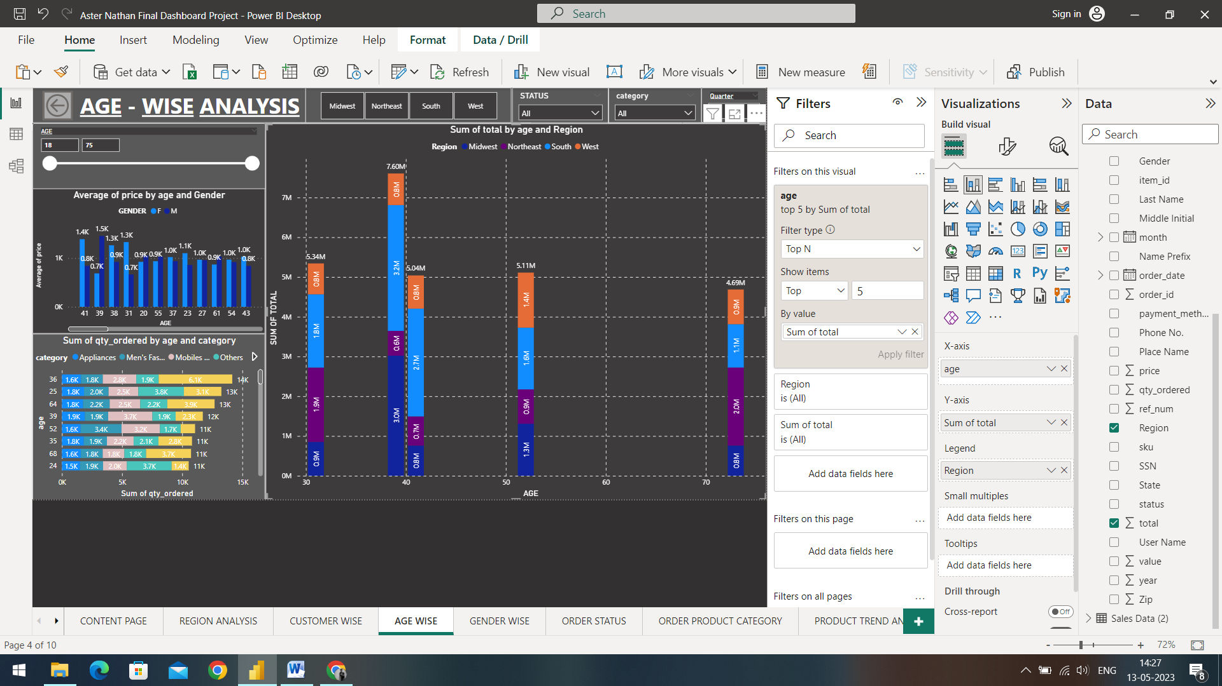

The top 5 age groups with the most amount of sales are as follows:

1. Age 39 contributing with 7.60 Million of Total sales
2. Age 31 contributed with the total sales of 5.34 Million
3. Age 52 contributed with 5.11 Million of Total sales
4. Age 41 contributed with the fourth most sales total with 5.04 Million
5. Age 72 contributed to be the fifth most sales with the total of 4.69 Million

* Ages between 30-40 generated the most amount of Total:
* The customers of Age 39 generated the most amount of total with a whopping 7.60 Million Sales followed by Age 31 which generated the second most amount of total compared to any other age group with 6.34 Million total.
* The region-wise trend for this age group is as follows:
* The South region of Age 39 generated the most amount of total with 32 Million of sales and the South region of Age 31 generated 18 Million of Total sales
* The Midwest region of Age 39 contributed to the second most sum of total with 30 Million of total Sales; however the Midwest region of Age 31 generated the third most sales in the specific age group with 0.9 Million sales.
* The West region of Age 39 generated the third most sum of total with 0.8 Million total sales, however the West region of Age 31 generated the least amount in the specific age group with just 0.8 Million sales
* The Northeast region contributed the least for the Age 39 of customers with just 0.6 Million total sales, however, the Northeast region of age 31 contributed to be the second most contributor with 1.9 Million total sales.
* Following on with the second age – 52:

It contributed to the total sales 5.11 Million total sales and third on the list with the most generated total.

* The region wise distribution are as follows:
* The South region contributed the most with 1.6 Million sales
* The second most profitable region is the West region with 1.4 Million sales
* The third region is the Midwest region with 1.3 Million sales.
* The least contributing region is the Northeast region with 0.9 Million sales
* Age 42 contributed to the be the fourth most profitable Age as it generated with 5.04 Million sales
* The region wise distribution are as follows:
* The South region contributed to be the most profitable of any other region with 2.7 Million sales being generated.
* The second most profitable region are the Midwest and West region contributing with the exact same amount with 0.8 Million of Total sales
* The least of the four regions is the Northeast region with just 0.7 Million of Total sales
* Age 72 contributed to be the fifth most contributed age group with 4.69 Million Total sales.
* The Northeast region contributed to be the most generated total sales with 20 Million of total sales
* The second most sales were contributed by the West region with 1.1 Million of total sales
* The West region contributed to be the third most contributed region with 0.9 Million of total sales
* The Midwest region contributed to be the least amongst the other regions with just 0.8 Million of Total sales.

Root Cause Analysis:

To improvise the pattern of growth for other age groups, we can conduct market research to understand the preferences, interests, and behaviours of different age groups. Develop targeted marketing campaigns for each age group. Develop products that appeal to different age groups. Consider factors such as functionality, design, and pricing to ensure that your products meet the needs and preferences. Provide excellent customer service that appeal to different age groups.

1. Percentage of Discount by Age:

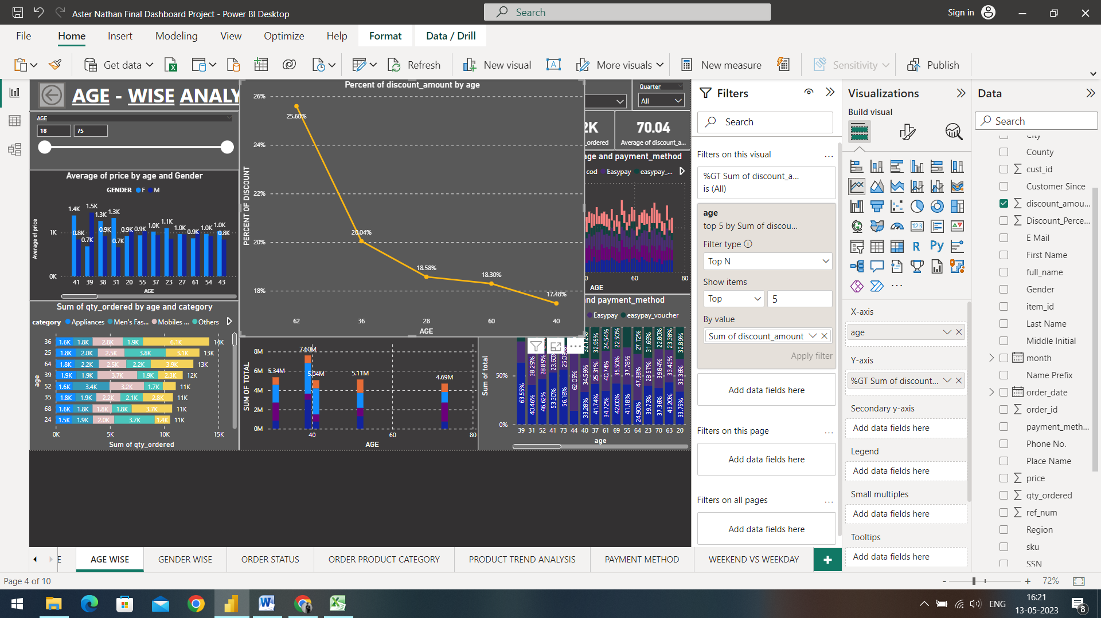

The graph above gives us an insight that the amount of discount given was different for different age groups.

* Customers of Age 62 have the highest discount percentage with 25.60% of total discount given.
* The second age group of customers are Age 36 where the percent of discount given was 20.04%
* The third most discount given was for the age of 28 where the discount percent was 18.58%
* Customers of Age 60 have the fourth most percent of discount given with 18.30% of total discounts.
* The fifth age group of customers are Age 40 where the percent of discount given was 17.48%

Root Cause Analysis:

In order to improve the discount trend, we can develop age-specific discount programs that are tailored to the needs and preferences of each age group. Partnering with organizations that serve specific age groups, such as schools or retirement communities. This can help you to reach new customers and increase awareness of your discount programs. Use social media to promote your discount programs to different age groups. Use email marketing to reach different age groups and promote your discount programs.

1. Sum of Quantity ordered by Age and Category:

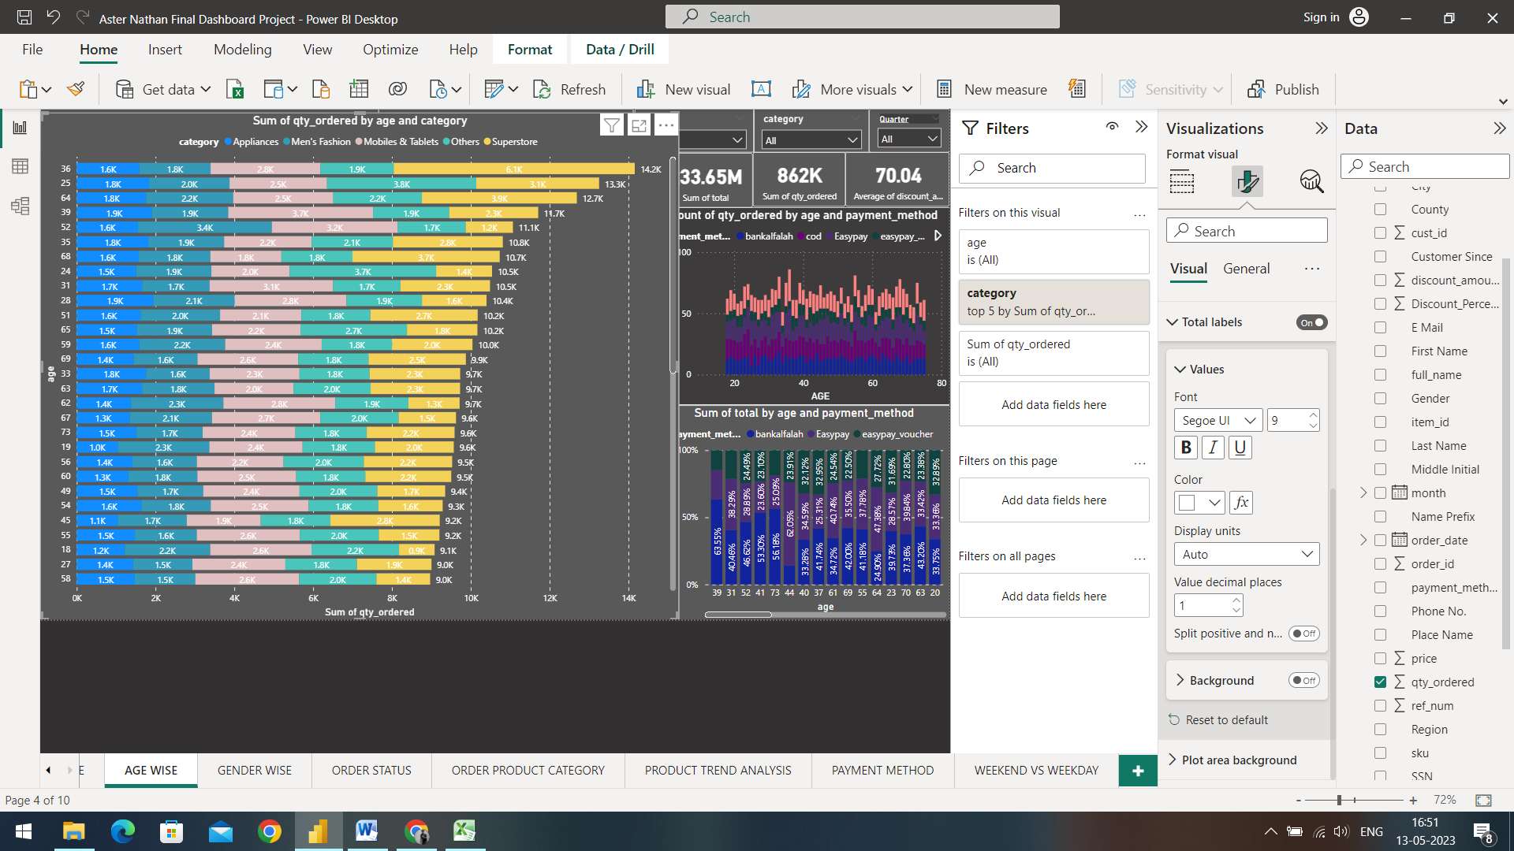

The chart above gives us an insight on the Customer Age that generated the most amount of quantities ordered and the product category they bought.

* Customers of Age 36 ordered the most quantity of products with 14.2K of total quantity. The product that contributed the most are as follows:
* The Superstore category drove the most amount of quantities for customers of age 36 as the category generated 6.1K of total quantities
* The second category contributing the most is the Mobile & Tablets category generating up to 2.8K of total quantities
* Customers of Age 25 contributed to be the second quantities ordered with 13.3K of total quantities ordered. The product that contributed are as follows:
* The Other product categories drove the most amounts of quantities for customers of age 25 as the category generated 3.8K of quantities ordered.
* The second category contributing the most is the Superstore category generating up to 3.1K of total ordered quantities.
* Customers of Age 64 contributed to be the third most quantities ordered by any age group with 12.7K of total quantities ordered. The product categories that contributed are as follows:
* The product category that contributed the most is the Superstore category with 3.9K of quantities ordered.
* The second category contributing the most is the Mobile & Tablets category with 2.5 K of quantities ordered
* Customers of Age 39 contributed to be the fourth quantities ordered by any age group with 11.7K of total quantities ordered. The product categories that contributed are as follows:
* The product category that contributed the most is the Mobile & Tablet category with 3.7K of total quantities ordered.
* The product category that contributes to be the second most quantities ordered is the Superstore category with 2.3K of total quantities ordered.
* Customers of Age 52 contributed to be the fourth quantities ordered by any age group with 11.7K of total quantities ordered. The product categories that contributed are as follows:
* The product category that contributed the most is the Appliances category with 3.4K of total quantities ordered.
* The product category that contributes to be the second most quantities ordered is the Mobile & Tablet category with 3.2K of total quantities ordered.

Key driving factors:

To target the best performing age groups, we can develop targeted marketing campaigns that appeal to our best performing age groups. Develop products that appeal to your best performing age groups. Consider factors such as functionality, design, and pricing to ensure that your products meet their needs and preferences. Provide excellent customer service that appeal to your best performing age groups.

1. Count of quantity ordered by Preferred payment mode:

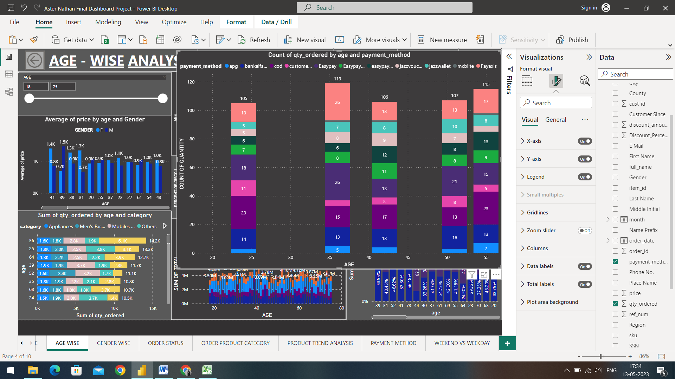

The chart above gives us an insight about the count of quantities ordered and the preferred payment mode.

* Customers of age 36 contributed to the distinct count of products bought, which stood at 119 distinct products bought. The preferred mode of payment are as follows:
* The payment method Payaxis and Easypay contributed to be the most preferred payment option with 26 counts of quantities ordered by either one of them.
* The second most preferred payment option is cod (Cash on Delivery) with 15 counts of quantities ordered by the payment mode.
* Customers of age 55 contributed second to the distinct count of products bought, which stood at 115 distinct products bought. The preferred mode of payment are as follows:
* The payment method cod (Cash on Delivery) contributed to be the most preferred payment option with 25 counts of quantities ordered by the method.
* The second most preferred payment option is Payaxis with 17 counts of quantities ordered by the payment mode.
* Customers of age 51 contributed to be the third most count of quantities ordered with 107 distinct products bought.
* The payment method Easypay with 21 distinct products bought by the mode of payment.
  + The second most preferred payment option is the bankalfalah mode of payment with 16 products bought with the mode of payment
* Customers of age 42 contributed to be the third most count of quantities ordered with 106 distinct products bought.
* The payment method Cod with 17 distinct products bought by the mode of payment.
  + The second most preferred payment option is the bankalfalah and Payaxis mode of payment with 13 products bought with the mode of payment
* Customers of age 24 contributed to be the third most count of quantities ordered with 105 distinct products bought.
* The payment method Cod with 23 distinct products bought by the mode of payment.
  + The second most preferred payment option is the Easypay mode of payment with 18 products bought with the mode of payment

Root Cause Analysis:

To increase the amount of quantities bought by the customer, we can create product bundles that include complementary items, encouraging customers to buy more. Offering discounts for customers who buy more quantities of a particular product. Provide facilities for customers to buy more, such as free shipping or a free gift for larger orders. Upsell and cross-sell products to customers when they are making a purchase.

1. **Gender-wise Analysis:**

Gender-wise analysis refers to the process of analysing customer data based on gender demographics. This type of analysis is commonly used to better understand the preferences and behaviour of customers within different gender groups and to identify opportunities for improving customer engagement and retention.

Overall, gender-wise analysis can provide valuable insights into the behaviour and preferences of customers within different gender groups. By using these insights to inform decision-making, businesses can improve customer engagement, retention, and satisfaction, driving overall business growth.

1. Sum of total by Year, Quarter and Gender:

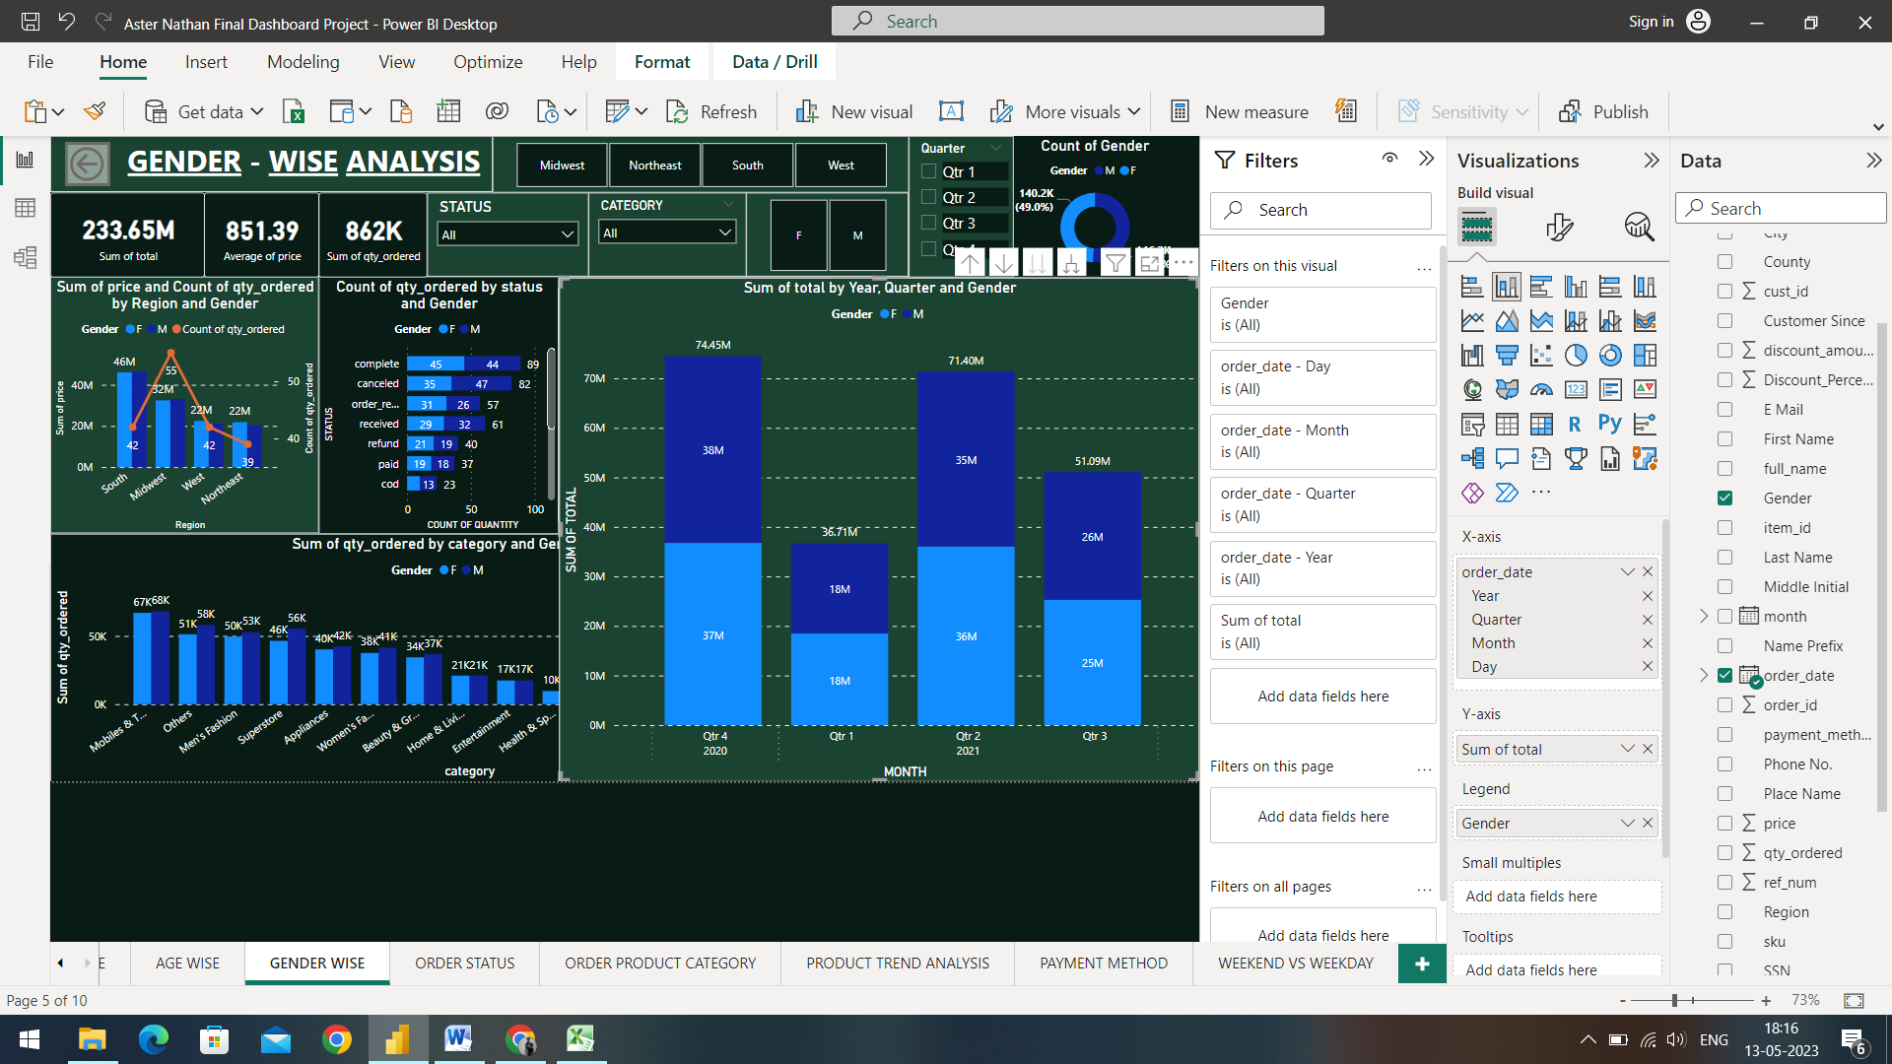The graph above displays the Sum of Quantity by region and the Quarters of the year 2021 and the 4th Quarter of the year 2020.

* The 4th Quarter of 2020 gives us an insight that the total amount of Quantities ordered was 74.45 Million, out of which, the most contributed Gender is the Male gender with 38 Million; followed by the Female Gender with 37 Million sum of total.
* The 1st Quarter of 2021 drove the least amount of total compared to the other quarters with a total of 36.71Million sum of total ordered and also gives us an insight that both the gender contributed equally with 18 Million sum of total by each gender.
* The 2nd Quarter of 2021 drove the second most amount of sales with 71.40 Million, out of which the Female gender contributed the most with 36 Million Sales and the Male gender contributing with 35 Million sales.
* The 3rd Quarter of 2021 gives us an insight that the total amount of Quantities ordered was 51.09 Million, out of which, the most contributed Gender is the Male gender with 26 Million; followed by the Female Gender with 25 Million sum of total

Key Driving Factors:

The above pattern and analysis gives us an insight on the customer behaviour patterns based on the Gender of the customers and no significant pattern is observed as both the genders are performing significantly equal in terms to drive the total sales.

1. Sum of Quantity by Category and Gender

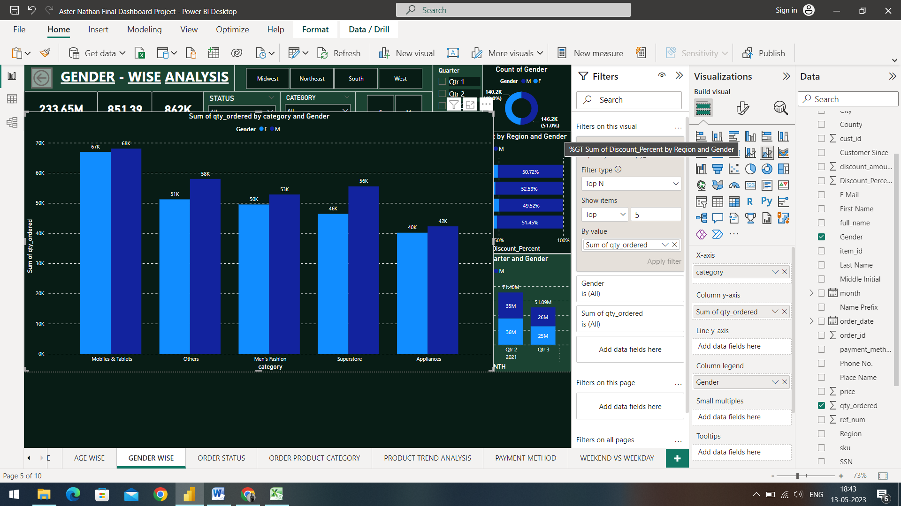

The graph above gives us an insight on the sum of quantities ordered by the top 5 Category of products and Gender

* Mobile and Tablets were the products that were bought the most, out of which, the Male Gender bought the most amount if this category with 68K followed by the Female Gender with 67K total quantities bought.
* The Other categories of product were the second most bought category in terms of quantity. The Male gender contributed the most with 58K sum of quantities bought by the gender, followed by the Female gender with 51K sum of quantities.
* The third most quantitative product is the Men’s Fashion wherein the Male Gender bought 53K sum of quantity, followed by the Female Gender with 50K sum of quantity.
* The Superstore category of products contributed to be the fourth most quantitative category, the Male gender contributed with 56K sum of quantities, followed by the Female Gender with 46K sum of quantities ordered.
* The fifth most quantitative product is the Appliance category wherein the Male Gender bought 42K sum of quantity, followed by the Female gender with 40K sum of quantity.

Key Driving Factors:

Similar to the previous pattern, the above patterns of quantities bought by customers based on gender does not give much of a pattern as the quantities are ordered almost equally to each other.

1. Percentage of Sum of Discount by Region and Gender:

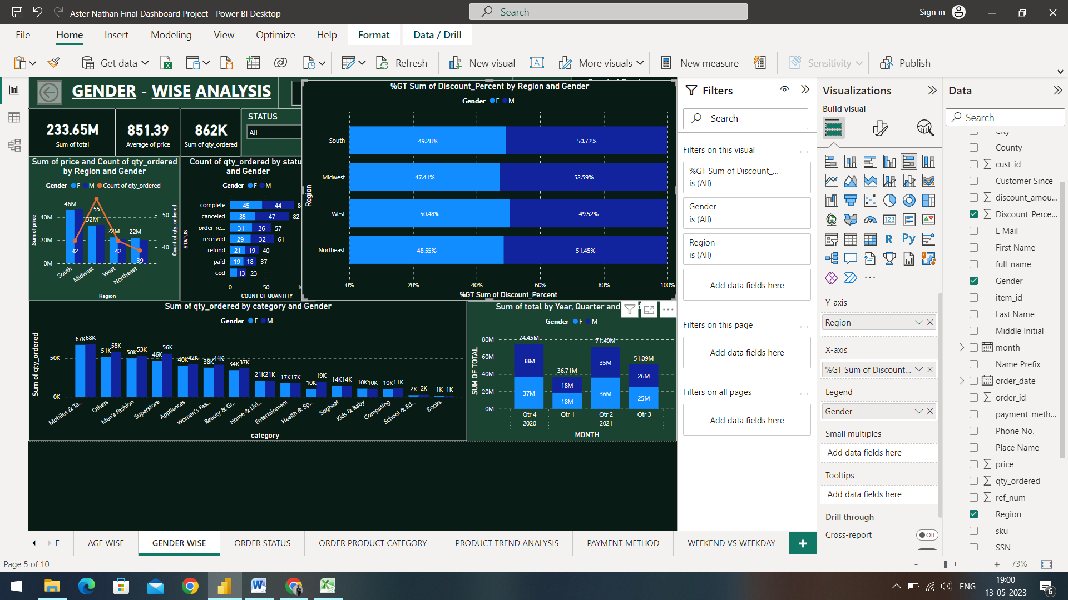

The percentage chart above gives us an insight on the percentage of discount based on Gender and the regional difference.

* The South region displays a pattern that out of the total 100%, 50.72% of Discounts was given to the Male gender and the remaining 49.28% of Discounts was preferred to the Female Customers.
* The Midwest region displays a pattern that 52.59% of the discounts were given to the Male Customers and the remaining 47.41% of Discounts was preferred to the Female Customers.
* The West region gives an insight that 50.48% of the discounts were preferred to the Female gender and the remaining 49.52% was given to the Male Gender.
* The Northeast region displays a pattern that 51.45% of the discounts were given to the Male Gender and the remaining 48.55% were preferred to the Female Customers.

Root Cause Analysis:

As we can see from the above pattern, the discount is not properly distributed among gender and is slightly towards the favour of the Male Gender, and in order to improve this pattern, we can use gender-neutral marketing strategies that appeal to all customers. Offer personalized discounts based on customer behaviour or preferences, rather than gender. Develop products that appeal to all customers and are inclusive of diverse needs and preferences. Consider factors such as design, functionality, and pricing to ensure that your products are accessible to everyone.

1. **Order Status:**

Order status is a critical aspect of the customer experience, as it provides customers with important information about the status of their orders. Providing timely and accurate updates on order status can help to build customer trust and confidence, leading to improved customer satisfaction and loyalty.

1. Count of Completed and Cancelled orders by count of quantity and Year, Quarter:

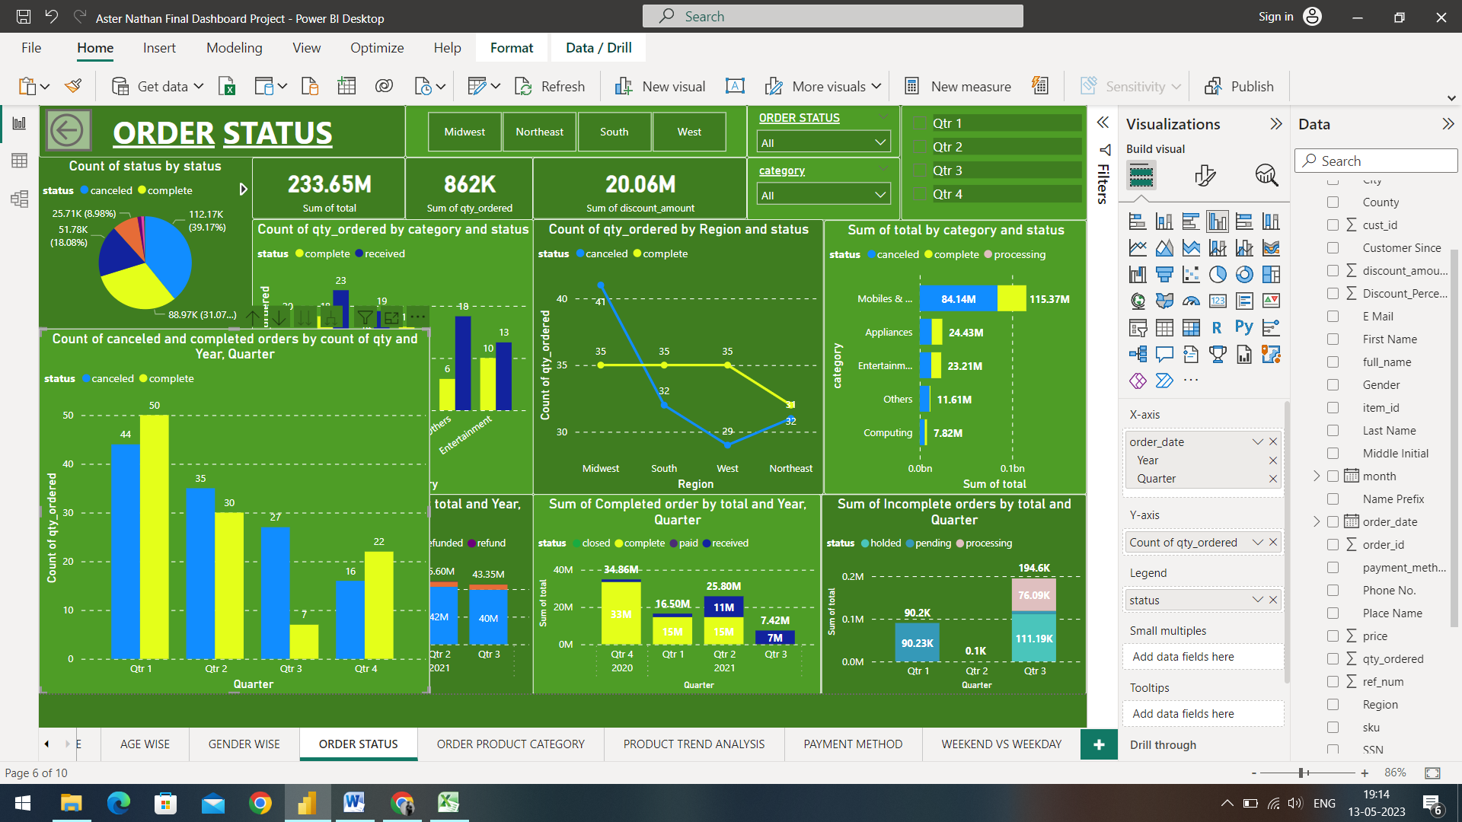

The graph above gives us an insight about the Cancelled and Completed orders by Year and Quarter.

* The 4th Quarter of 2020 gives us an insight that out of the total amount of Quantities ordered, 50 orders were completed and 44 orders were cancelled.
* The 1st Quarter of 2021 gives us an insight that 35 Orders were Cancelled and 30 Orders were Completed.
* The 2nd Quarter of 2021 drove the least amount of quantities ordered with 7 quantities of Orders being Completed and 27 quantities of Orders being Cancelled
* The 3rd Quarter of 2021 gives us an insight that out of the total amount of Quantities ordered, 22 Orders were completed and the 16 Orders were cancelled.

Root Cause Analysis:

By the above Analysis, we can observe that in some quarters the trend of cancelled orders is more than that of complete orders, in order to improve this pattern and equalize the ratio, we can improve communication with your customers can help to reduce the number of cancelled orders. Provide customers with clear and accurate product information, shipping details, and expected delivery times. Ensure that the products you sell meet high standards of quality. This can help to reduce the number of cancelled orders due to defective or unsatisfactory products. Offer customers the option to exchange or return products that they are not satisfied with. This can help to reduce the number of cancelled orders and increase customer satisfaction. Provide excellent customer service that is responsive to the needs and concerns of your customers.

1. Sum of Total by Cancelled Orders:

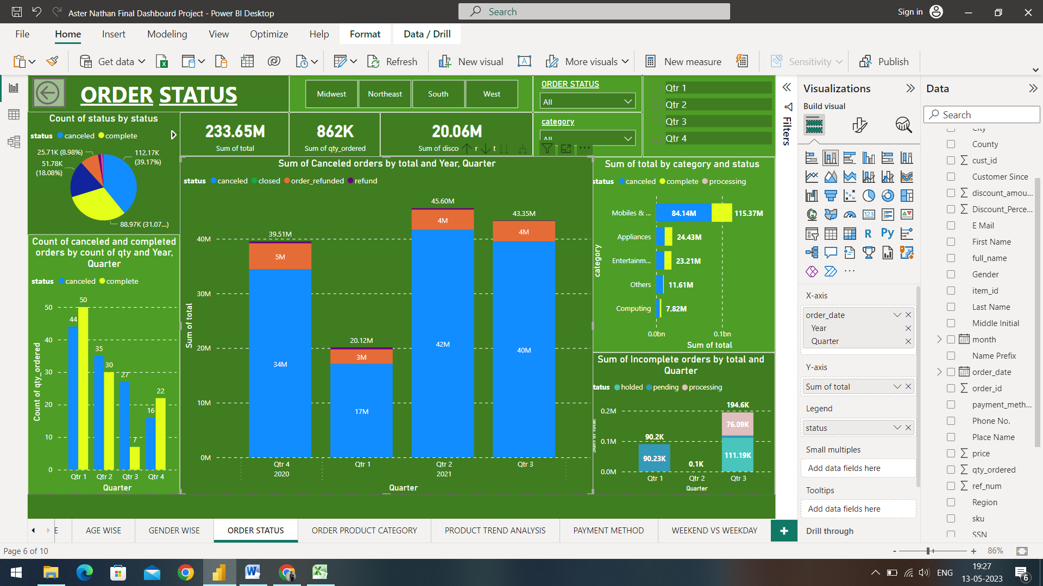

The graph above gives us an insight on the Sum of total by Year and Quarter and the Cancelled orders with legends like Cancelled, Closed, Refunded Orders and Refund Applications.

* The 4th Quarter of 2020 gives us an insight that out of the total orders of 39.51 Million, 34 Million orders were cancelled, 5 Million were Refunded Orders and 320.2K orders were applied for a Refund.
* The 1st Quarter of 2021 gives us an insight that out of the total orders of 20.12 Million, 17 Million orders were cancelled, 3 Million were Refunded Orders and 340.9K orders were applied for a Refund.
* The 2nd Quarter of 2021 gives us an insight that out of the total orders of 45.60 Million, 42 Million orders were cancelled, 4 Million were Refunded Orders and 360.9K orders were applied for a Refund.
* The 3rd Quarter of 2021 gives us an insight that out of the total orders of 43.35 Million, 40 Million orders were cancelled, 4 Million were Refunded Orders and 69K orders were applied for a Refund.

Root Cause Analysis:

Refer to the Root Cause Analysis of the previous pattern in order to improvise the trend of Cancelled orders.

1. Sum of Completed Orders by Total and Year, Quarter

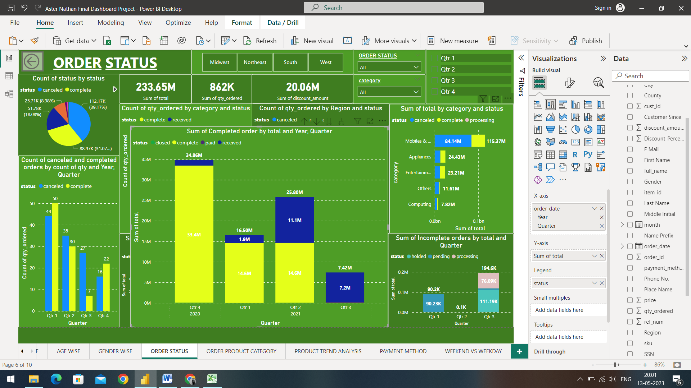

The graph above gives us an insight on the Sum of total by Year and Quarter and the Completed orders with legends like Complete, Closed, Paid and Received.

* The 4th Quarter of 2020 gives us an insight that out of the total orders of 34.86 Million, 33.4 Million orders were completed, 1.3 Million were received.
* The 1st Quarter of 2021 gives us an insight that out of the total orders of 16.50 Million, 14.6 Million orders were completed, 1.9 Million were received
* The 2nd Quarter of 2021 gives us an insight that out of the total orders of 25.80 Million, 14.6 Million orders were completed, 11.1 Million were received
* The 3rd Quarter of 2021 gives us an insight that out of the total orders of 7.42 Million, 7.2 Million orders were received.

Key Driving Factors:

With the above, we can also see a positive pattern of products in reference to the completed orders and the orders received by the customers, in order to boost the completed orders, we can provide accurate and detailed information about our products, such as product descriptions, images, specifications, and reviews can help customers make informed purchasing decisions. Establishing a trustworthy reputation through positive reviews, testimonials, and customer feedback can help to build trust and increase customer confidence in your brand. Providing reliable customer support that is responsive to customer needs and concerns can help to resolve issues quickly and prevent cancelled orders. Providing timely shipping and delivery of orders can help to build customer loyalty and increase the likelihood of completed orders.

1. Sum of Incomplete Orders by Year, Quarter

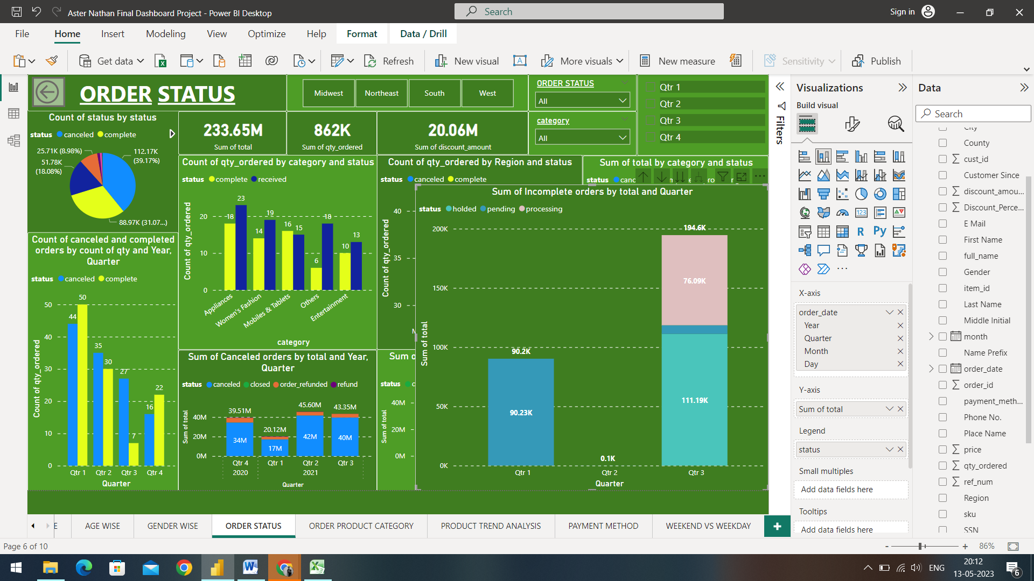

The graph above gives us an insight on the Sum of total by Year and Quarter and the incomplete orders with legends like holded, pending and processing.

* The 1st Quarter of 2021 gives us an insight that out of the total order status of 90.2 K, All the orders have the pending status
* The 2nd Quarter of 2021 gives us an insight that out of the total order status of 0.1K, none of the orders have a pending status
* The 3rd Quarter of 2021 gives us an insight that out of the total order status of 194.6 K, 11.19K orders are holded, 7.3K orders are pending and 76.09K orders are processing.

Root Cause Analysis:

Pending orders can negatively impact the overall efficiency and effectiveness of our business operations. In order to improvise this trend, we can implement inventory management systems that allow you to accurately track your stock levels; this can help to reduce the likelihood of backorders and pending orders. Providing reliable and responsive customer support to address any concerns or issues that customers may have with their orders. This can help to prevent cancellations or abandoned orders. We can also monitor your business metrics, including the number of pending orders, to identify trends and areas where you can improve your processes.

1. Trend of Cancelled and Completed Orders by Product Categories:

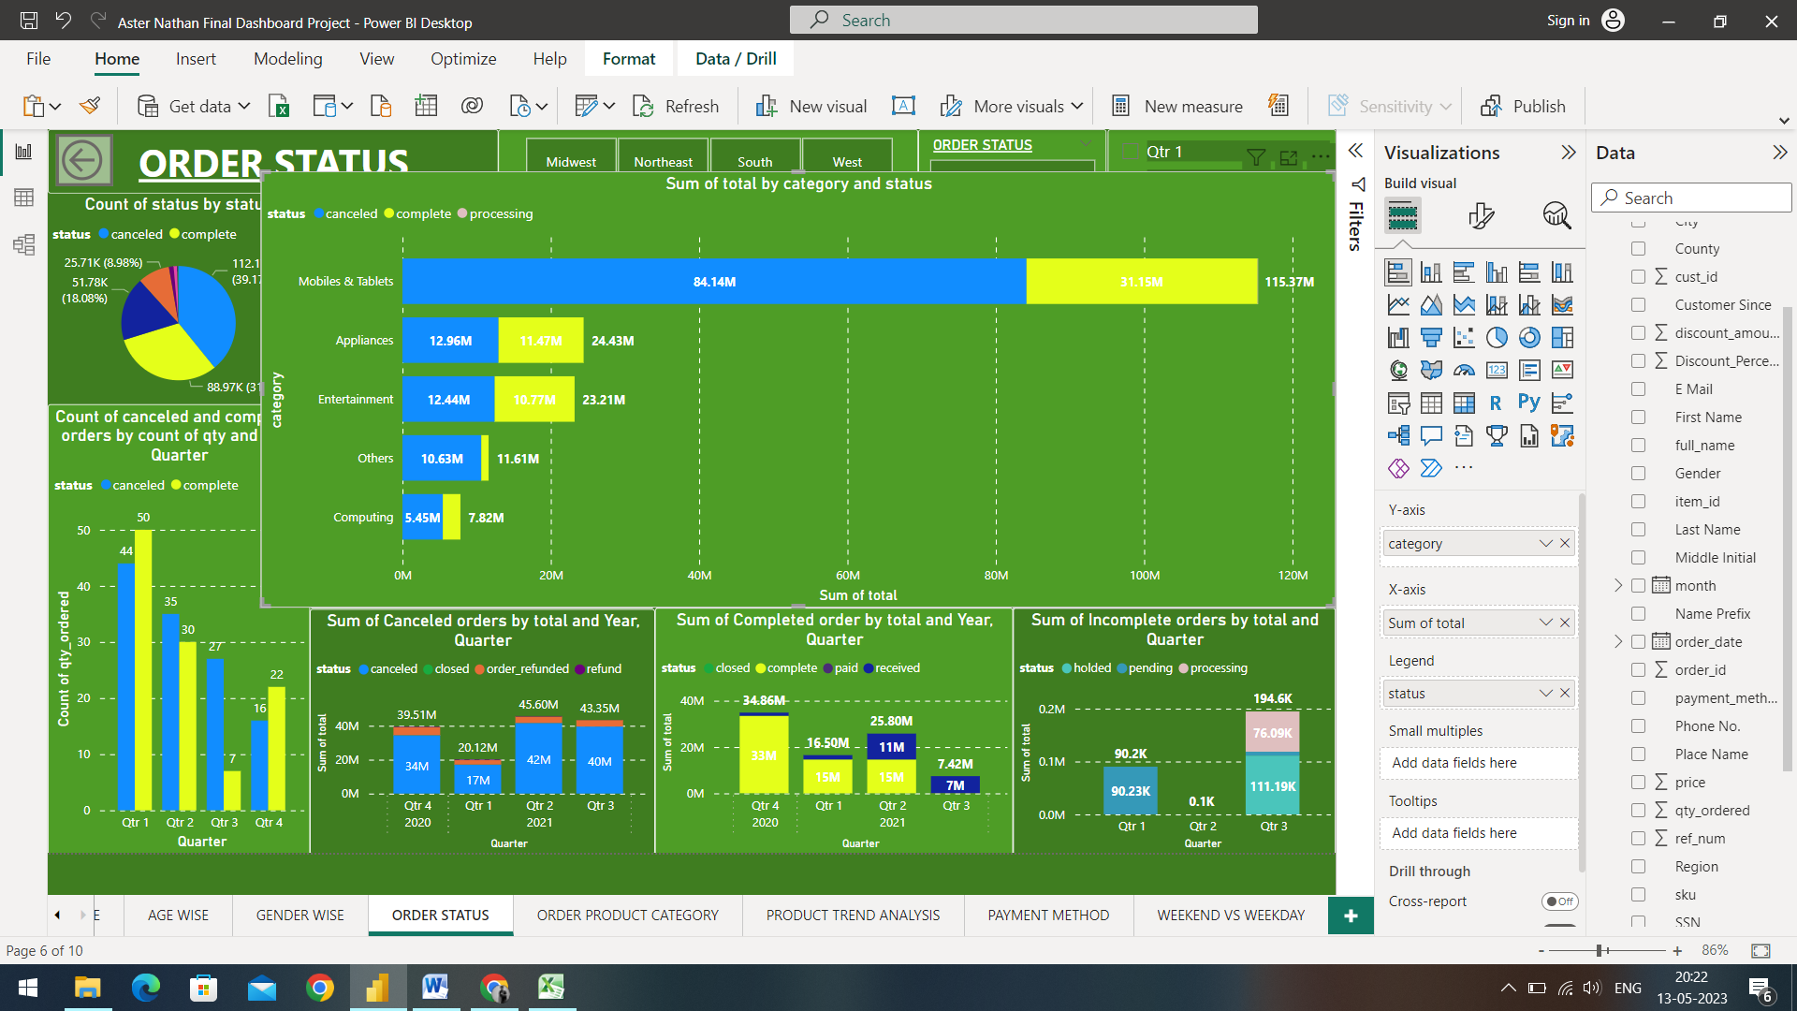

The graph above gives us an insight about the Cancelled and Completed orders by Different Categories of products.

* Mobile and Tablets have a total sum of 115.37 Million of Cancelled and Completed status, out of which 84.14 Million of orders have a Cancelled sum total and the remaining 31.15 Million have a Completed sum total.
* Appliances have a total sum of 24.43 Million of Cancelled and Completed status, out of which 12.96 Million of orders have a Cancelled sum total and the remaining 11.47 Million have a Completed sum total
* Entertainment have a total sum of 23.21 Million of Cancelled and Completed status, out of which 12.44 Million of orders have a Cancelled sum total and the remaining 10.77 Million have a Completed sum total
* Other product categories have a total sum of 11.61 Million of Cancelled and Completed status, out of which 10.63 Million of orders have a Cancelled sum total and the remaining 980K have a Completed sum total
* Computing have a total sum of 7.82 Million of Cancelled and Completed status, out of which 5.45 Million of orders have a Cancelled sum total and the remaining 2.37 Million have a Completed sum total

Root Cause Analysis:

To improve the ratio of cancelled and completed orders for specific product categories, we can analyse our sales data to identify which product categories have a higher rate of cancelled orders. Look for patterns in customer behaviour, such as common reasons for cancellations, and identify areas where you can make improvements. Ensure that our products are of high quality and meet or exceed customer expectations. Analyse your pricing strategy to ensure that your products are priced competitively.

1. **Order Product Category:**

Product category is an important aspect of a business's product strategy and marketing efforts. A product category is a grouping of products that share similar characteristics or serve similar functions. Examples of product categories include electronics, clothing, home goods, and beauty products.

Product category is an important element of a business's product strategy, helping to guide decisions around product development, marketing, and resource allocation. By understanding their customers' needs and preferences, businesses can create product categories that align with their target audience and drive long-term success.

1. Sum of total by Year, Quarter and Category:

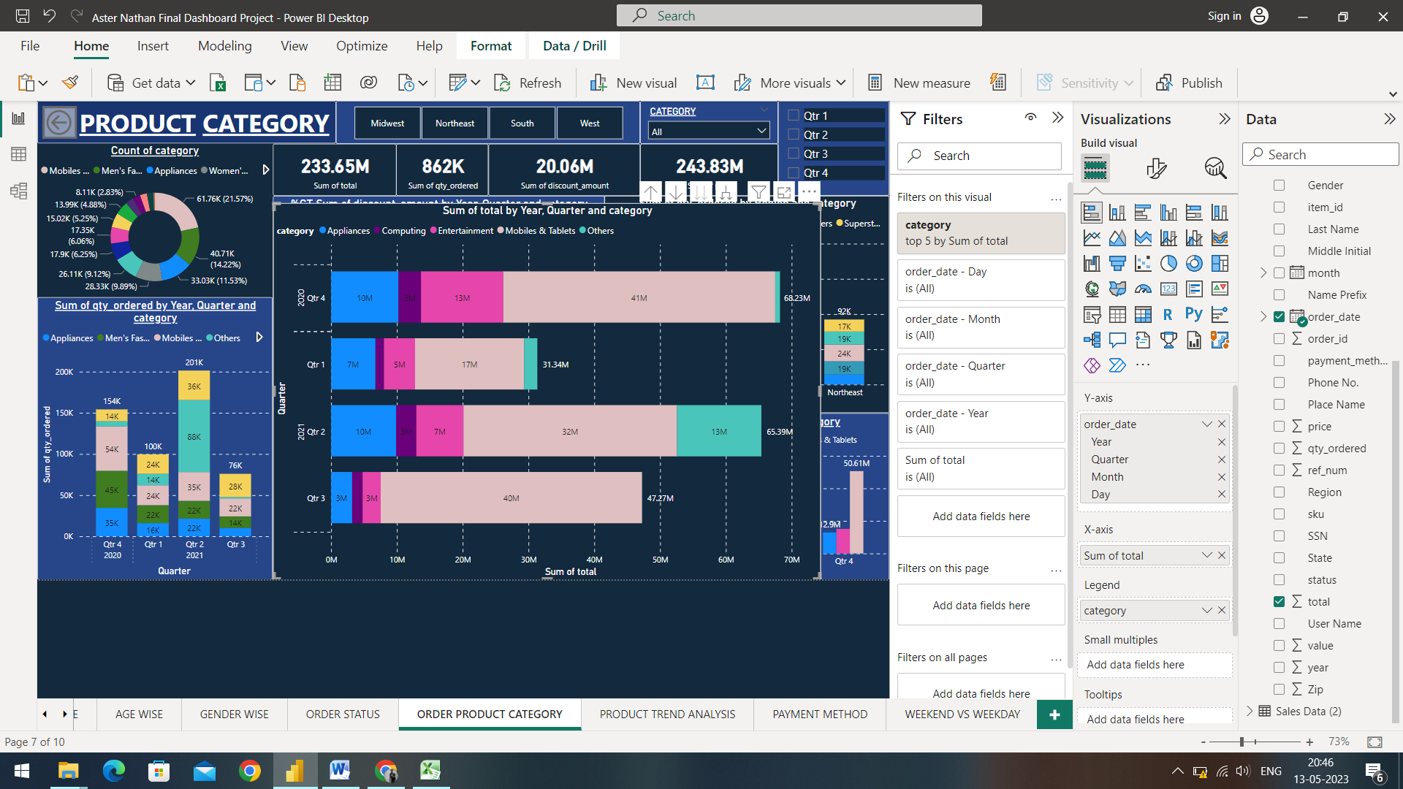

The chart above gives us an insight on the Sum of total based on category of products and the Year, Quarter.

* The 4th Quarter of 2020 gives us an insight that out of the total products sum of 68.23 Million, 41Million total sum were generated from the Mobiles & Tablets, 13 Million were generated from Entertainment, Appliances generated 10 Million and Computing generated just 3 Million
* The 1st Quarter of 2021 gives us an insight that out of the total products sum of 31.34 Million, 17Million total sum were generated from the Mobiles & Tablets, 5 Million were generated from Entertainment, Appliances generated 7 Million and Computing generated 1.2 Million
* The 2nd Quarter of 2021 gives us an insight that out of the total products sum of 65.39 Million, 32Million total sum were generated from the Mobiles & Tablets, 13 Million were generated from Other product category, Appliances generated 10 Million, Entertainment contributed with 7Million and Computing generated 3 Million
* The 3rd Quarter of 2021 gives us an insight that out of the total products sum of 47.27 Million, 40Million total sum were generated from the Mobiles & Tablets, 3 Million were generated from Entertainment, Appliances also generated 3 Million and Computing generated 1.5 Million.

Root Cause Analysis:

To improve the trend of underperforming product categories, we can conduct market research to identify the needs and preferences of your target audience. We can consider offering bundles of underperforming products with other products that are selling well. This can increase the perceived value of the underperforming product. Providing reliable and responsive customer support to address any concerns or issues that customers may have with the product. This can help to increase customer loyalty and improve sales over time.

1. Sum of Quantity ordered by Year, Quarter and Category

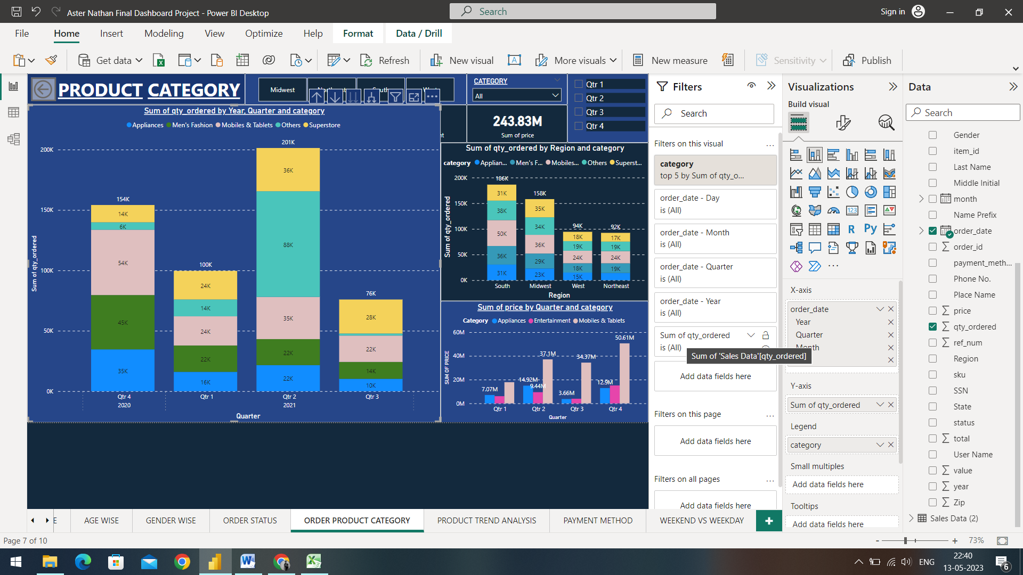

The chart above gives us an insight about the Total sum of Quantities bought based on the Product Categories and Year and Quarter.

* The 4th Quarter of 2020 gives us an insight that out of the total sum of quantity ordered of 154K, 54K total sum were generated from the Mobiles & Tablets, 43K were generated from Men’s Fashion, Appliances generated 35K, Superstore contributed with 14K and Other product categories generated 6K.
* The 1st Quarter of 2021 gives us an insight sum of quantity ordered of 100K, 24K total sum were generated from the Mobiles & Tablets, 22K were generated from Men’s Fashion, Appliances generated with 16K, Superstore contributed with 24K and Other product categories generated 14K.
* The 2nd Quarter of 2021 gives us an insight sum of quantity ordered of 201K, 35K total sum were generated from the Mobiles & Tablets, 22K were generated from Men’s Fashion, Appliances generated with 22K, Superstore contributed with 36K and Other product categories generated 88K.
* The 3rd Quarter of 2021 gives us an insight sum of quantity ordered of 76K, 22K total sum were generated from the Mobiles & Tablets,14K were generated from Men’s Fashion, Appliances generated with 10K, Superstore contributed with 28K and Other product categories generated 1K sum of quantity.

Root Cause Analysis:

In order to increase the sum of quantity based on product category, we can bundle complementary products together, offering them at a discounted price compared to buying each item individually. Also offering an upgraded version of a product or suggest a higher-priced product in the same category that might better fit the customer's needs. Offering discounts or promotions on a specific product category or a group of products to encourage customers to buy more.

1. Average Price by Region based on Product Category and Quarter

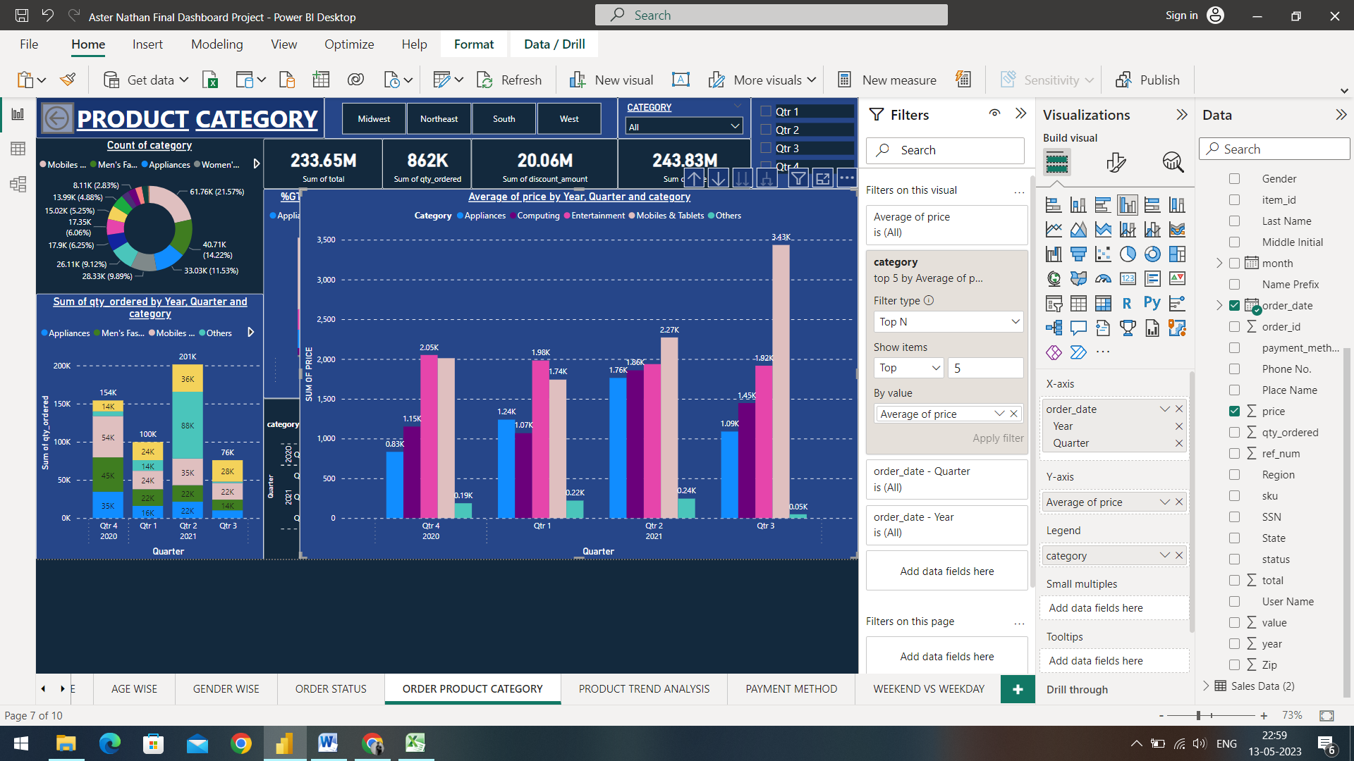

The visual above gives us an insight on the increase of average prices of different product categories over the course of Year Quarters.

* The 4th quarter of 2020 gives us an insight that the prices of the top 5 performing were moderate compared to the other quarters and the prices were as follows; the Entertainment category had an average price of $2.05K, followed by the Mobiles & Tablets category with an average price of $2.01K, Computing prices had an average of $1.15K and the Appliance category with $0.83K of Average price, the Other product categories had an average price of 0.19K
* The 1st quarter of 2021 gives us an insight that the prices of the top 5 performing were very low compared to the other quarters and the prices were as follows; the Entertainment category had an average price of $1.98K, followed by the Mobiles & Tablets category with an average price of $1.74K, Computing prices had an average of $1.07K and the Appliance category with $1.24K of Average price, the Other product categories had an average price of 0.22K
* The 2nd quarter of 2021 gives us an insight that the prices of the top 5 performing products were moderate compared to the other quarters and the prices were as follows; the Entertainment category had an average price of $1.9K, followed by the Mobiles & Tablets category with an average price of $2.27K, Computing prices had an average of $1.86K and the Appliance category with $1.76K of Average price, the Other product categories had an average price of 0.24K
* The 3rd quarter of 2021 gives us an insight that the prices of the top 5 performing were very high compared to the other quarters and the prices were as follows; the Entertainment category had an average price of $1.92K, followed by the Mobiles & Tablets category with an average price of $3.43K, Computing prices had an average of $1.45K and the Appliance category with $1.09K of Average price, the Other product categories had an average price of 0.05K, which was very low for this specific category.

Root Cause Analysis:

To boost products based on region, we can invest in advertising campaigns that specifically target customers in the region where we want to boost our products. We can also consider adjusting our product pricing to better appeal to customers in the region. This could include offering discounts or promotions that are specific to the region.

1. Percentage of the Sum of discount by Product category and Region

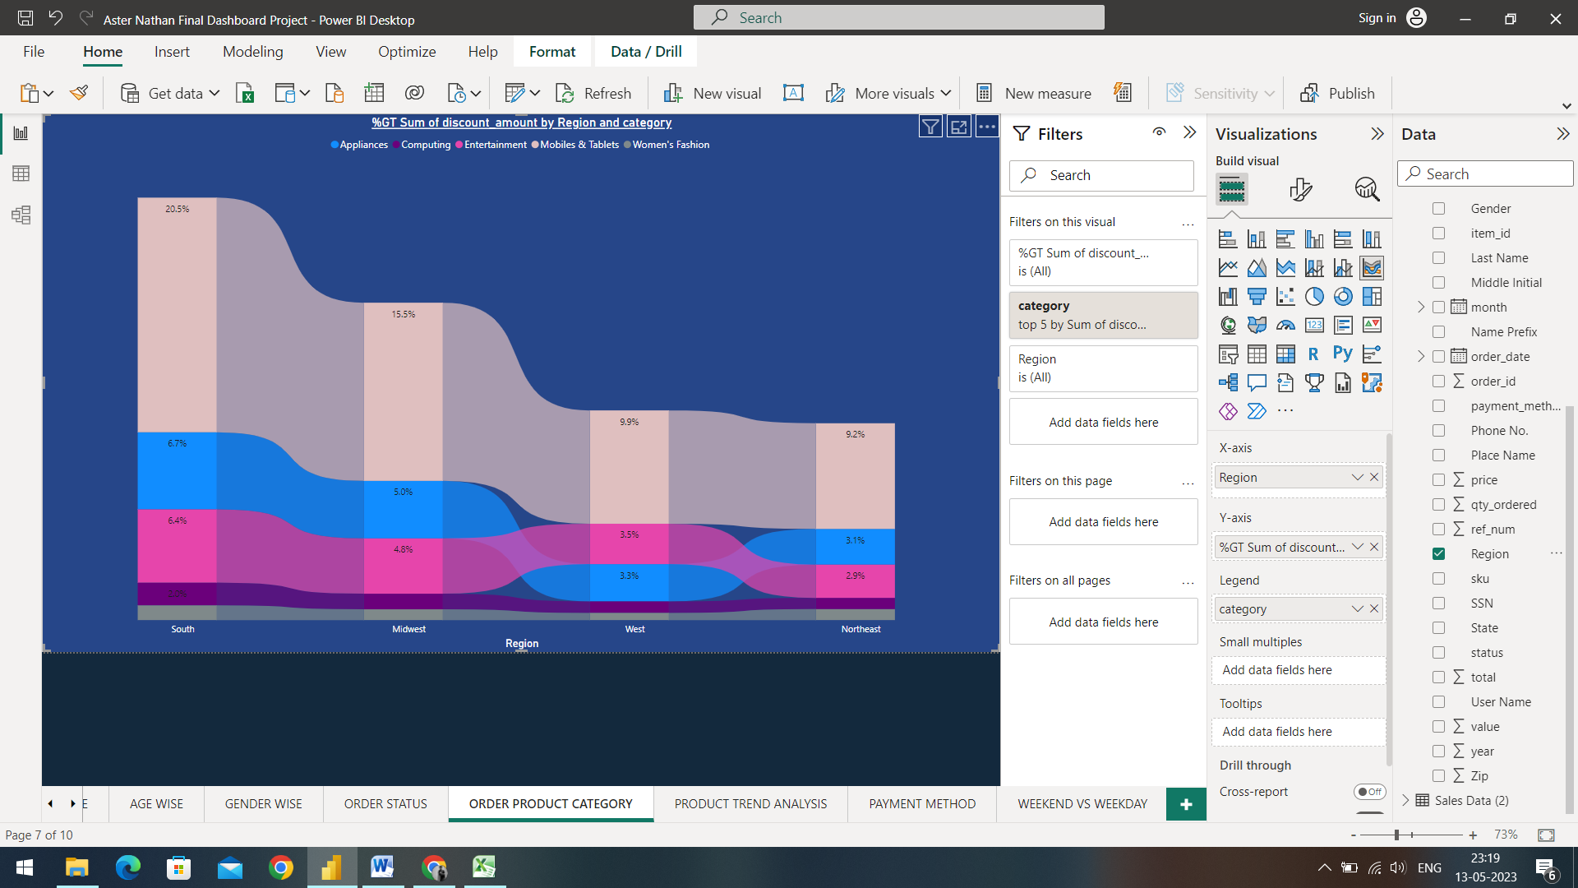

The chart gives us an insight of the trend of discount based on Different regions and product category

* The customers in the South region were given the most amount of Discounts compared to the other regions with the Mobiles & Tablets being given the most discount with 20.5% of discount amount, followed by the Appliances category with 6.7% of discount amount, the Entertainment category was given 6.4% of discount and the computing category was given 2.0% of discount amount and the Women’s fashion category was given 1.28% of discount amount
* The customers in the Midwest region were given the most amount of Discounts compared to the other regions with the Mobiles & Tablets being given the most discount with 15.5% of discount amount, followed by the Appliances category with 5.0% of discount amount, the Entertainment category was given 4.8% of discount and the computing category was given 1.3% of discount amount and the Women’s fashion category was given 0.94% of discount amount
* The customers in the West region were given the most amount of Discounts compared to the other regions with the Mobiles & Tablets being given the most discount with 9.9% of discount amount, followed by the Appliances category with 3.3% of discount amount, the Entertainment category was given 3.5% of discount and the computing category was given 1.0% of discount amount and the Women’s fashion category was given 0.6% of discount amount
* The customers in the Northeast region were given the most amount of Discounts compared to the other regions with the Mobiles & Tablets being given the most discount with 9.2% of discount amount, followed by the Appliances category with 3.1% of discount amount, the Entertainment category was given 2.9% of discount and the computing category was given 0.9% of discount amount and the Women’s fashion category was given 0.9% of discount amount

Key Driving Factors:

As we can observe the trend and by the earlier observations, we can say that the discount given to specific products boosts the sales of the products irrespective of time and region. So, in order to boost the sales of other underperforming products, we can implement a limited-time offer to increase the sales and the amount of quantities bought by the customers.

1. **Product Trend Analysis:**

Analysing trends in product categories can help businesses to stay ahead of changing customer preferences and to identify growth opportunities. By understanding which categories are growing in popularity, businesses can develop targeted marketing strategies and invest in product development to meet the evolving needs of their customers.

1. Up-trending products by Sum of total and Product Categories:

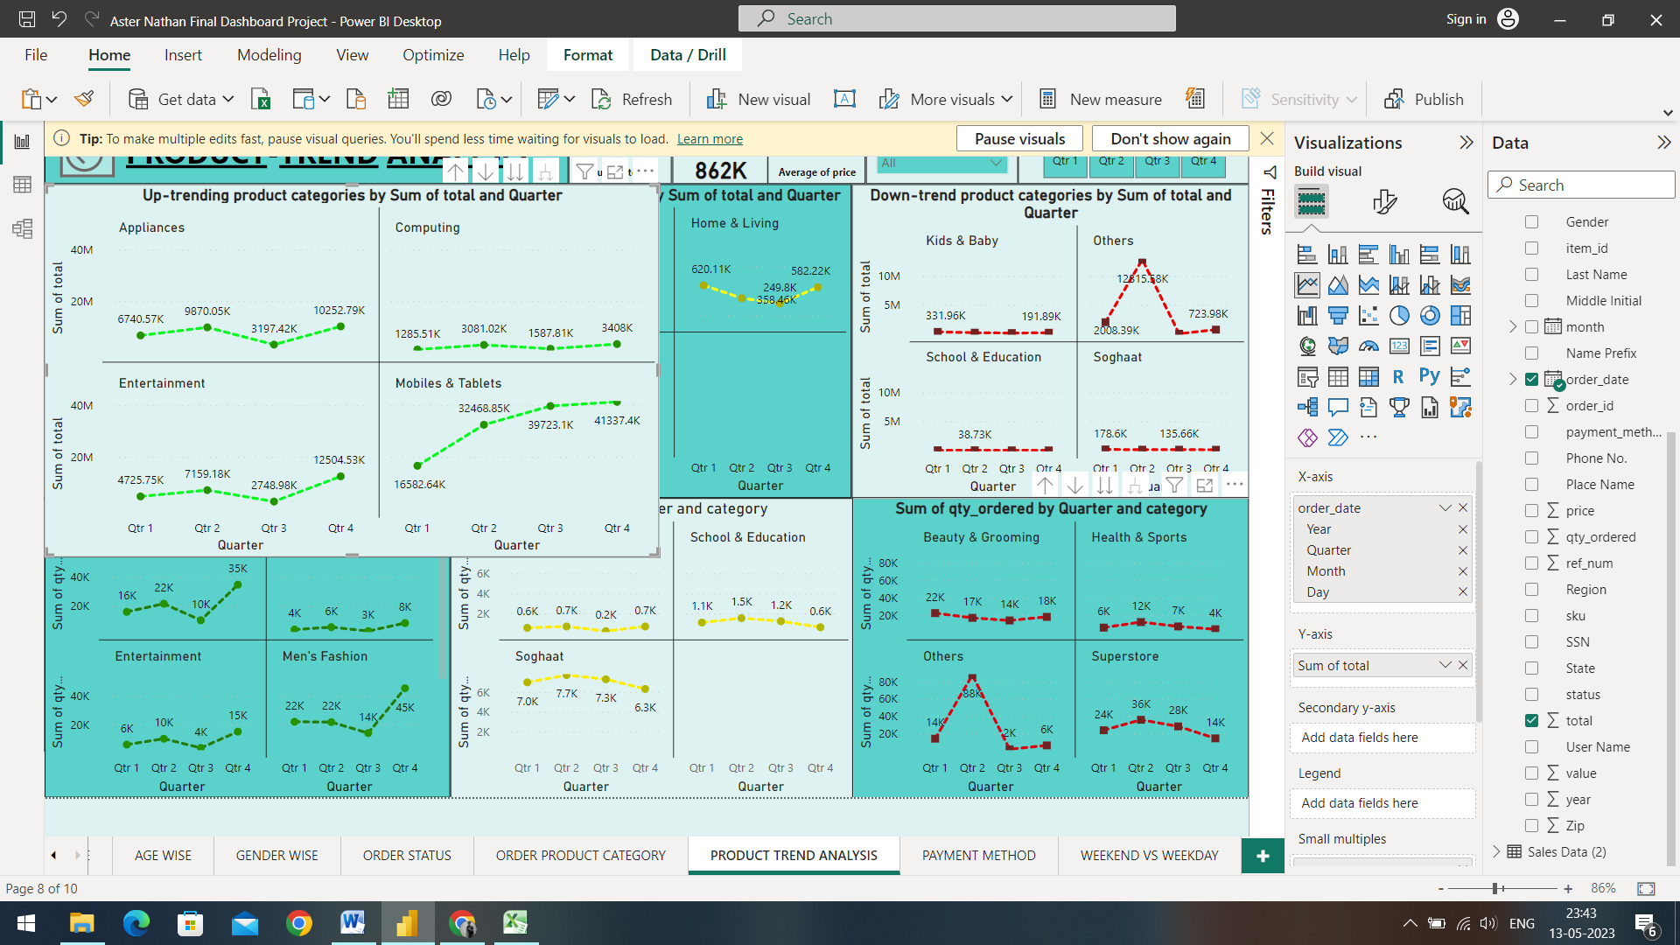

The chart above gives us an insight on the different products that follow an Uptrend based on different Quarters of a year

* The category of Appliances had begun with 6740.57K in the first quarter, increased to 9870.05K in the second quarter, then dropped 3197.42K in the third quarter and then increased approximately double the amount with 10252.79K.
* The category of Computing had begun with 1285.51K in the first quarter, increased to 3081.02K in the second quarter, then dropped 1587.81K in the third quarter and then increased to 3408K.
* The category of Entertainment had begun with 4725.75K in the first quarter, increased to 7159.18K in the second quarter, then dropped 2748.98K in the third quarter and then increased approximately thrice the amount with 12504.53K.
* The category of Mobiles & Tablets had begun with 16582.64K in the first quarter, increased to 32468.85K in the second quarter, it increased 39723.1K in the third quarter and then increased approximately thrice the amount with 41337.4K

1. Up-trending products with sum of quantity bought:

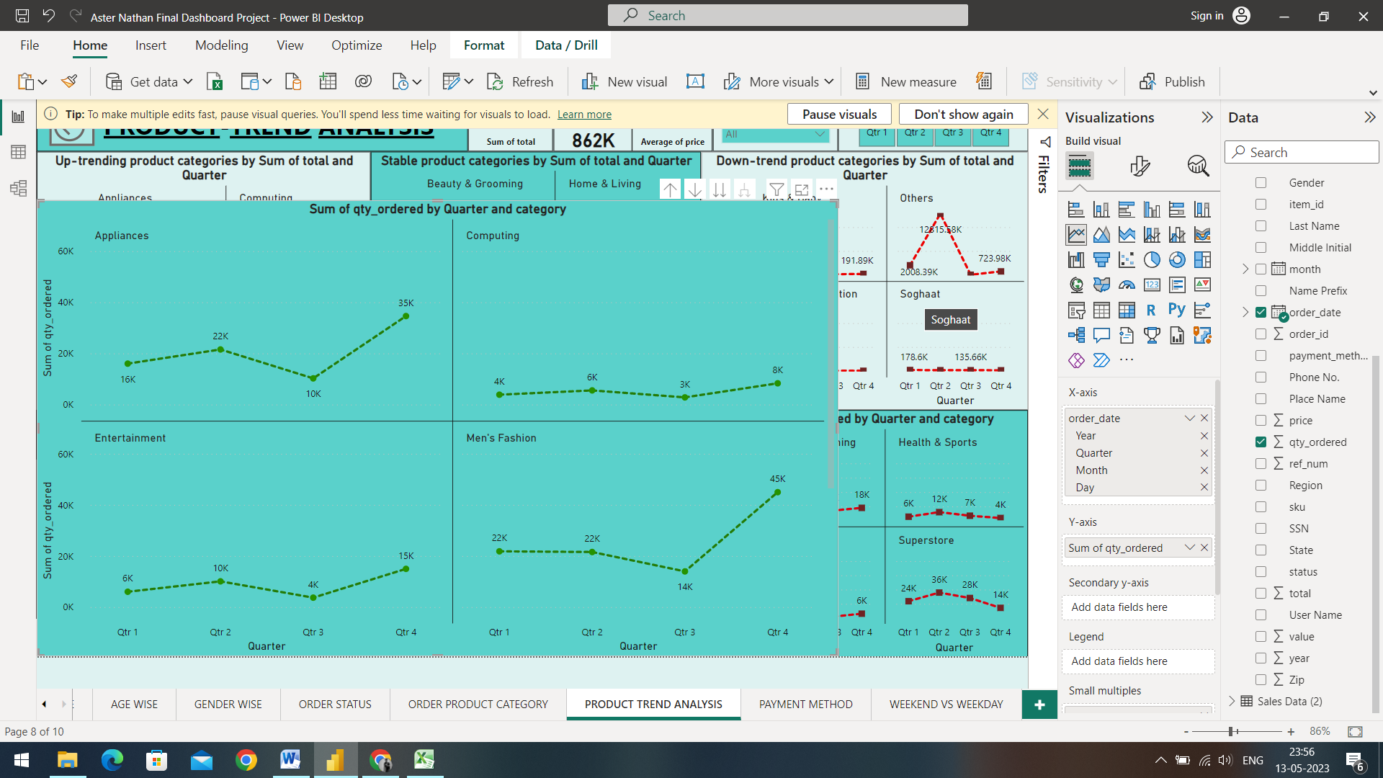

The chart above gives us an insight on the sum of quantities of products that follow an Uptrend based on different Quarters of a year

* The category of Appliances had begun with 16K in the first quarter, increased to 22K in the second quarter, then dropped to 10K in the third quarter and then increased approximately double the amount with 35K.
* The category of Computing had begun with 4K in the first quarter, increased to 6K in the second quarter, then dropped to 3K in the third quarter and then increased to 8K.
* The category of Entertainment had begun with 6K in the first quarter, increased to 10K in the second quarter, then dropped 4K in the third quarter and then increased more than twice the amount with 15K.
* The category of Mobiles & Tablets had begun with 22K in the first quarter, remained the same in the second quarter, it decreased down to 14K in the third quarter and then increased massively with 45K.

Key Driving Factors of Both Up-trending products sum and quantity:

There could be several reasons why a product is up-trending. Certain products may experience increased demand during specific times of the year. When a product gains traction on social media platforms, it can quickly become up-trending. Products that are new or innovative may attract attention and uptrend as customers seek out the latest and greatest offerings. A well-executed marketing campaign can help increase awareness and interest in a product, leading to an uptrend in sales.

1. Stable Products by sum of total and Product Categories:

Stable products are those type of products that remained the same from the 1st quarter till the 4th quarter

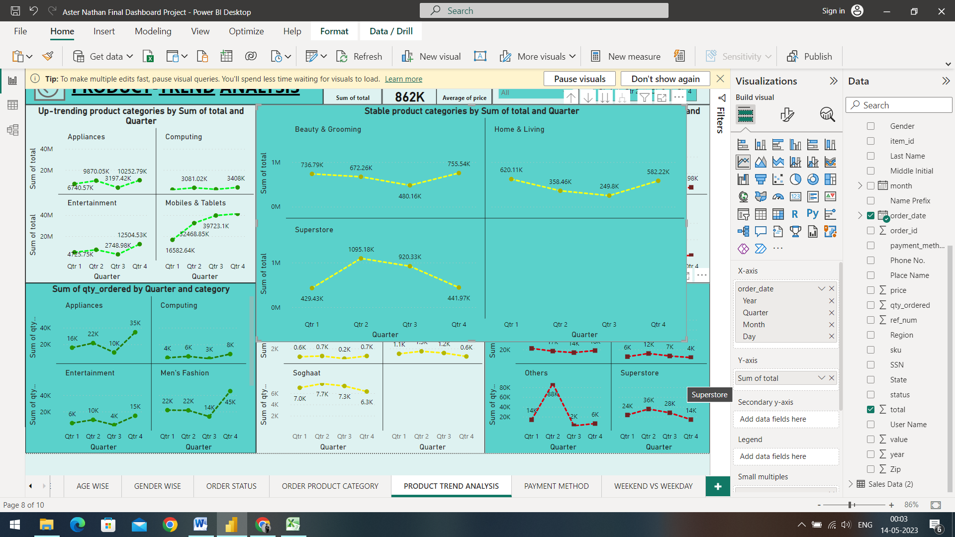

The chart above gives us an insight on the product that started with the 1st Quarter and ended up being the same total at the 4th quarter.

* Beauty and Grooming began with 736.79K in the first quarter, then decreased to 672.26K in the second quarter, had a downfall to 480.16K and increased to 755.54K, but slightly remained the same starting from the 1st quarter to the 4th quarter
* Home and Living began with 620.11K in the first quarter, decreased to 358.46K, had a downfall to 249.8K and increased to 582.22K, although the product category couldn’t decrease or increase a massive amount, it falls under the stable product category.
* Superstore category began with 429.43K in the first quarter, increased to more than double with 1095.18K , decreased to 920.33K and decreased massively to 441.97K.

Root Cause Analysis:

Improving the trend of stable products can be challenging since they are already established and may not be experiencing significant growth or decline. However, we can gain a deeper understanding of the customers and their needs to identify opportunities for improving the product. Consider making improvements or updates to the product to make it more appealing to customers. Develop and execute targeted marketing campaigns to increase visibility and generate interest in the product. Evaluate the pricing of the product and consider adjusting it to better appeal to customers.

1. Down-trend products with Sum of total:

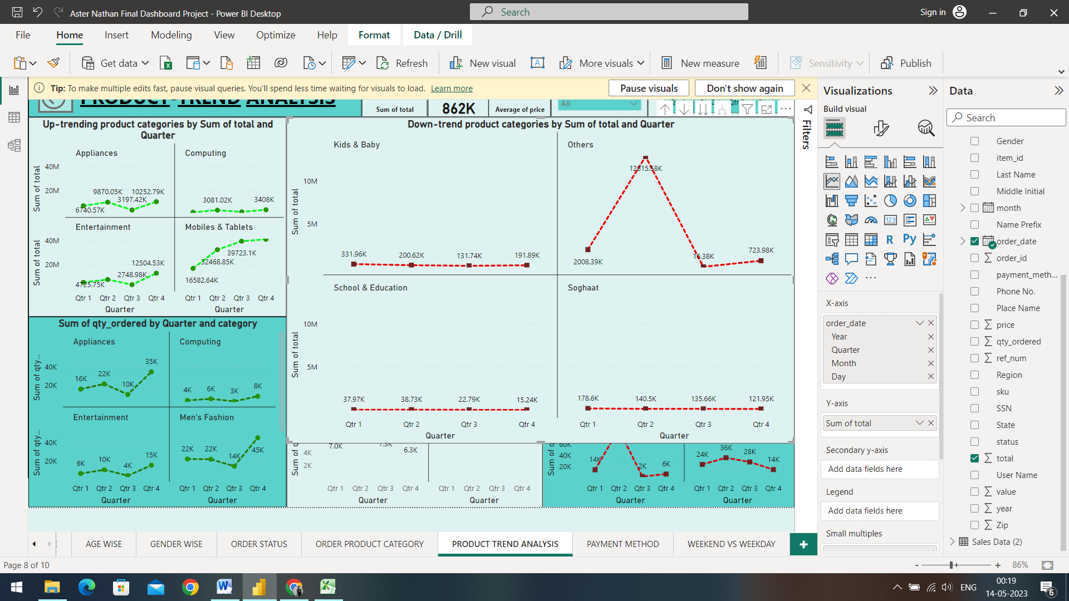

The chart above gives us an insight on the different products that follow a Down-trend based on different Quarters of a year

* The category of Kids & Baby had begun with 331.96K in the first quarter, decreased to 200.62K in the second quarter, then dropped to 131.74K in the third quarter and then decreased down to the amount with 191.89K.
* The Other categories of product had begun with 2008.39K in the first quarter, increased ten times to 12815.58K in the second quarter, then dropped massively to 16.38K in the third quarter and then increased slightly to 723.98K.
* The category of School & Education had begun with 37.97K in the first quarter, increased slightly to 38.73K in the second quarter, then dropped to 22.79K in the third quarter and then dropped down to 15.24K.
* The category of Soghaat had begun with 178.6K in the first quarter, decreased to 140.5K in the second quarter, it decreased more to 135.66K in the third quarter and then dropped down to 121.95K

1. Down-trend of Products with the Sum of quantities bought:

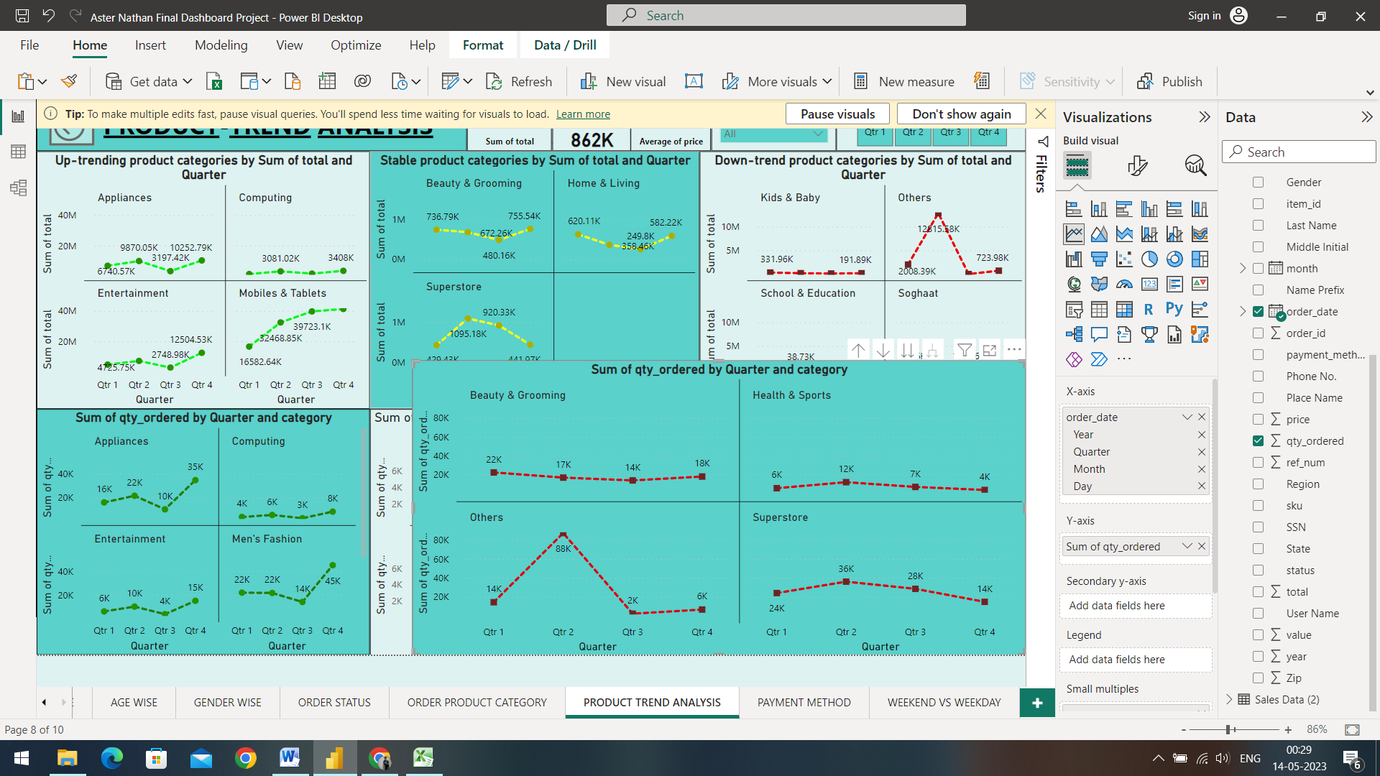

The chart above gives us an insight on the different products that follow a Down-trend based on different Quarters of a year

* The category of Beauty & Grooming had begun with 22K in the first quarter, decreased to 17K in the second quarter, then dropped to 14K in the third quarter and then increased slightly to the quantity with 18K.
* The Health & Sports category had begun with 6K in the first quarter, increased to 12K in the second quarter, then dropped down to 7K in the third quarter and then decreased to 4K.
* The Other category of products had begun with 14K in the first quarter, increased massively to 88K in the second quarter, then dropped to 2K in the third quarter and then increased slightly to 6K.
* The category of Superstore had begun with 24K in the first quarter, increased to 36K in the second quarter, it decreased down to 28K in the third quarter and then dropped down to 14K.

Root Cause Analysis of Down-trending products Sum and Quantity:

When a product is down trending, it's important to conduct a root cause analysis to identify the underlying issues and develop a plan of action to address them. Reviewing sales data to determine when the down trend started and to identify any patterns or trends that may have contributed to the decline in sales. This could include changes in market demand, competition, pricing, or product availability. Gain insights into why customers may be less interested in the product by conducting surveys, focus groups, or one-on-one interviews. Ask customers about their reasons for not purchasing the product and for feedback on potential improvements. Based on your analysis, develop a plan of action to address the root cause of the down trend. This could involve making changes to product design, pricing, marketing, or distribution strategies.

1. **Payment Patterns:**

Payment method analysis refers to the process of analysing customer payment preferences to identify trends and patterns in payment behaviour. By understanding which payment methods are most popular among customers, businesses can make informed decisions around payment processing and optimize their payment strategies to improve customer satisfaction and financial performance.

1. Sum of total by Year, Quarter and payment method

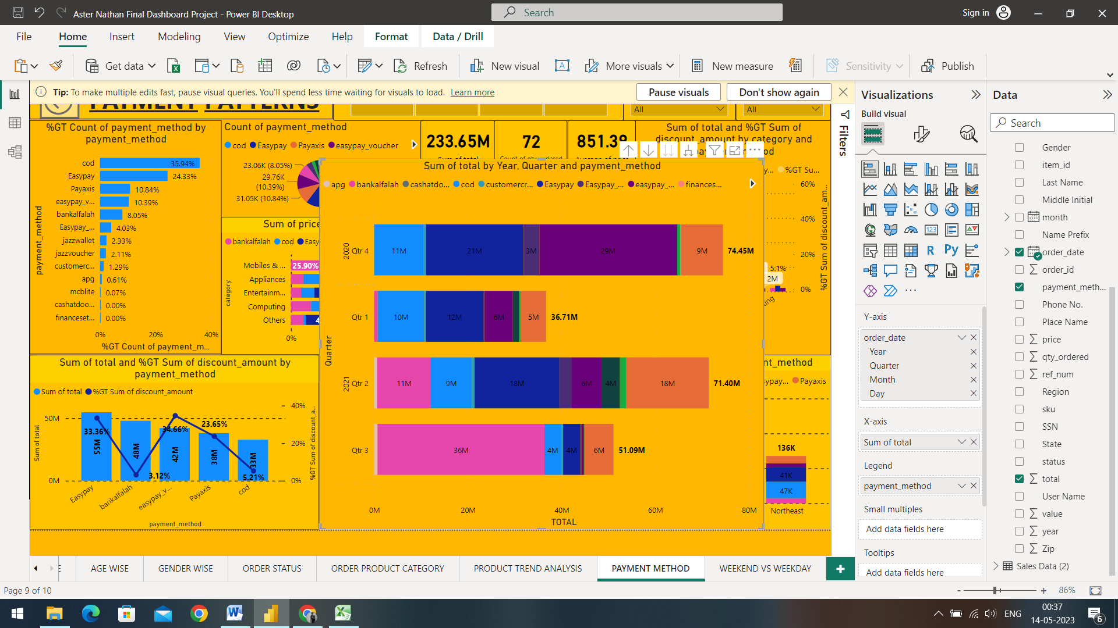

The chart above gives us an insight on the payment method preferred by the customers over different quarters of a year

* The 4th Quarter of 2020 gives us an insight that out of the total sum of total based on payment methods of 74.45 Million, 29M of total sum was preferred from the Easypay_MA, 21M were preferred from Easypay mode of payment and cod (cash on delivery) was preferred with 11M
* The 1st Quarter of 2021 gives us an insight that out of the total sum of total based on payment methods of 36.71 Million, 12M of total sum was preferred from the Easypay, 10M were preferred by COD mode of payment and Easypay_MA was preferred with 6M
* The 2nd Quarter of 2021 gives us an insight that out of the total sum of total based on payment methods of 71.40 Million, 18M of total sum was preferred from the Payaxis, 18M were preferred from Easypay mode of payment and bankalfalah mode of payment was preferred with 11M
* The 3rd Quarter of 2021 gives us an insight that out of the total sum of total based on payment methods of 51.09 Million, 36M of total sum was preferred from the bankalfalah mode of payment, 6M were preferred from pay axis mode of payment and cod (cash on delivery) along with Easypay was preferred with 4M customers.

Root Cause Analysis:

When conducting a root cause analysis on payment method, you are trying to identify the underlying issues that are causing problems or issues related to the payment methods you offer, we can review payment data to identify patterns and trends that may be contributing to the problem. Look at metrics like payment success rates, payment processing times, and payment method usage rates. Gather feedback from customers to gain insights into their experiences with payment methods. Ask them about their preferred payment methods and any challenges they have encountered while making payments. Evaluate the payment process to identify any potential roadblocks or areas for improvement.

1. Percentage of the Sum of discount by Payment method

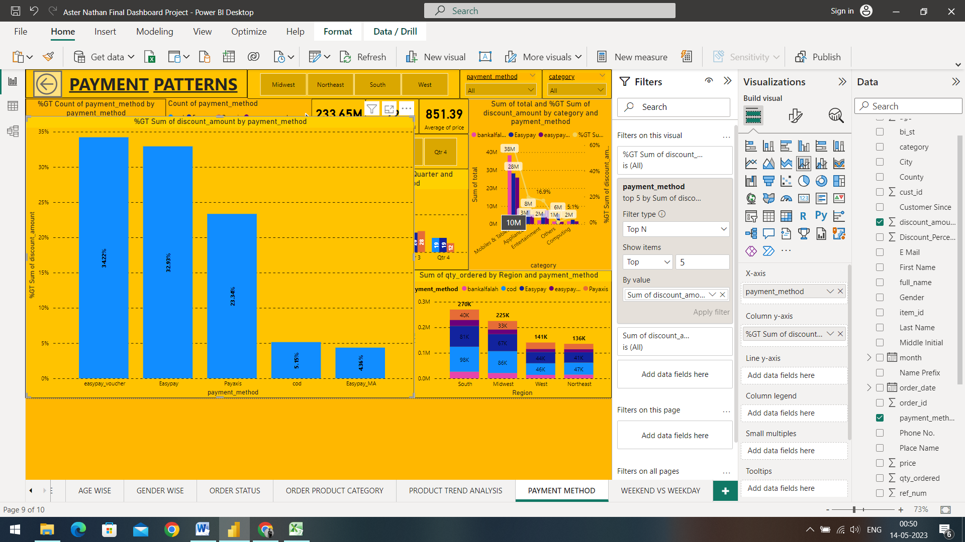

The chart gives us an insight of the trend of discount based on Different payment modes.

* The customers who preferred the easypay_voucher mode of payment were given the most amount of Discounts compared to the payment modes with the discount of 34.22% of discount amount
* The customers who preferred the Easypay mode of payment were given the second most amount of Discounts with the discount of 32.93% of discount amount
* The customers who preferred the Pay axis mode of payment were given the third most amount of Discounts with the discount of 23.34% of discount amount
* The customers who preferred the cod mode of payment were given the discounts of 5.15% of discount amount
* The customers who preferred the Easypay_MA mode of payment were given the discounts of 4.36% of discount amount

Key Driving Factors:

There are several key driving factors that can influence the success and popularity of payment methods. Customers expect payment methods to be easy to use and convenient. Security is a top concern for customers when it comes to payment methods. Customers want to be sure that their personal and financial information is protected when making online transactions. They also prefer payment methods that offer rewards or incentives, such as cash back or loyalty points that can be highly appealing to customers.

1. Count of Quantity ordered by Quarter and payment method

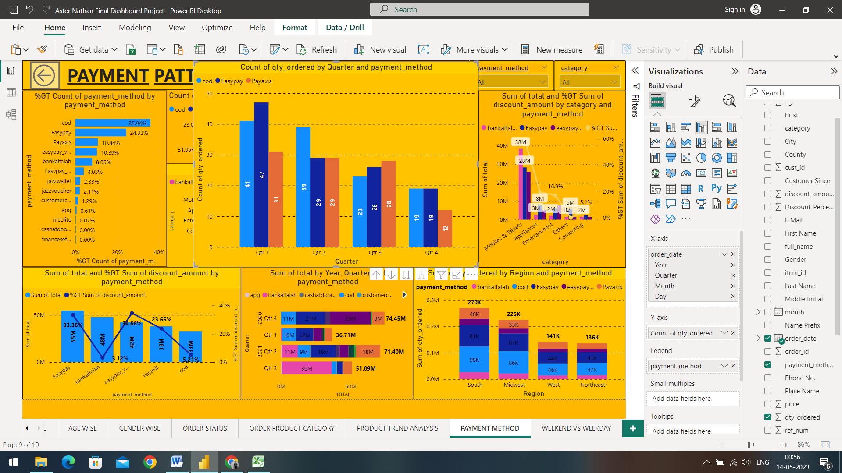

The chart above gives us an insight on the count of quantities ordered using the top 3 preferred mode of payments based on the Quarters.

* The 4th quarter of 2020 gives us an insight that the preferred mode of payment were as follows; the Easypay mode of payment was preferred for 19 distinct products, followed by the cod mode of payment 19 different products ordered, Pay axis was preferred for 12 distinct products.
* The 1st quarter of 2021 gives us an insight that the preferred mode of payment were as follows; the Easypay mode of payment was preferred for 47 distinct products, followed by the cod mode of payment 41 different products ordered, Pay axis was preferred for 31 distinct products.
* The 2nd quarter of 2021 gives us an insight that the preferred mode of payment were as follows; the Easypay mode of payment was preferred for 29 distinct products, followed by the cod mode of payment 39 different products ordered, Pay axis was preferred for 29 distinct products.
* The 3rd quarter of 2021 gives us an insight that the preferred mode of payment were as follows; the Easypay mode of payment was preferred for 26 distinct products, followed by the cod mode of payment 23 different products ordered, Pay axis was preferred for 28 distinct products.

Root Cause Analysis:

To increase the quantities bought based on preferred payment modes, we can review payment data to identify which payment methods are preferred by customers and which are associated with higher order volumes. We can also create targeted promotions and incentives to encourage customers to use preferred payment methods. Offering a range of payment methods to accommodate the preferences of different customers.

1. **Weekend Vs. Weekday Analysis:**

Weekend vs. weekday analysis refers to the process of analysing customer behaviour and sales patterns to identify differences in behaviour and preferences between weekdays and weekends. Weekend vs. weekday analysis can help businesses to improve their operations and optimize their resources to better meet customer needs and preferences. By continually monitoring and analysing customer behaviour across different days of the week, businesses can stay ahead of changing customer trends and improve their competitiveness in the market.

1. Weekend Analysis by sum of total and Region:

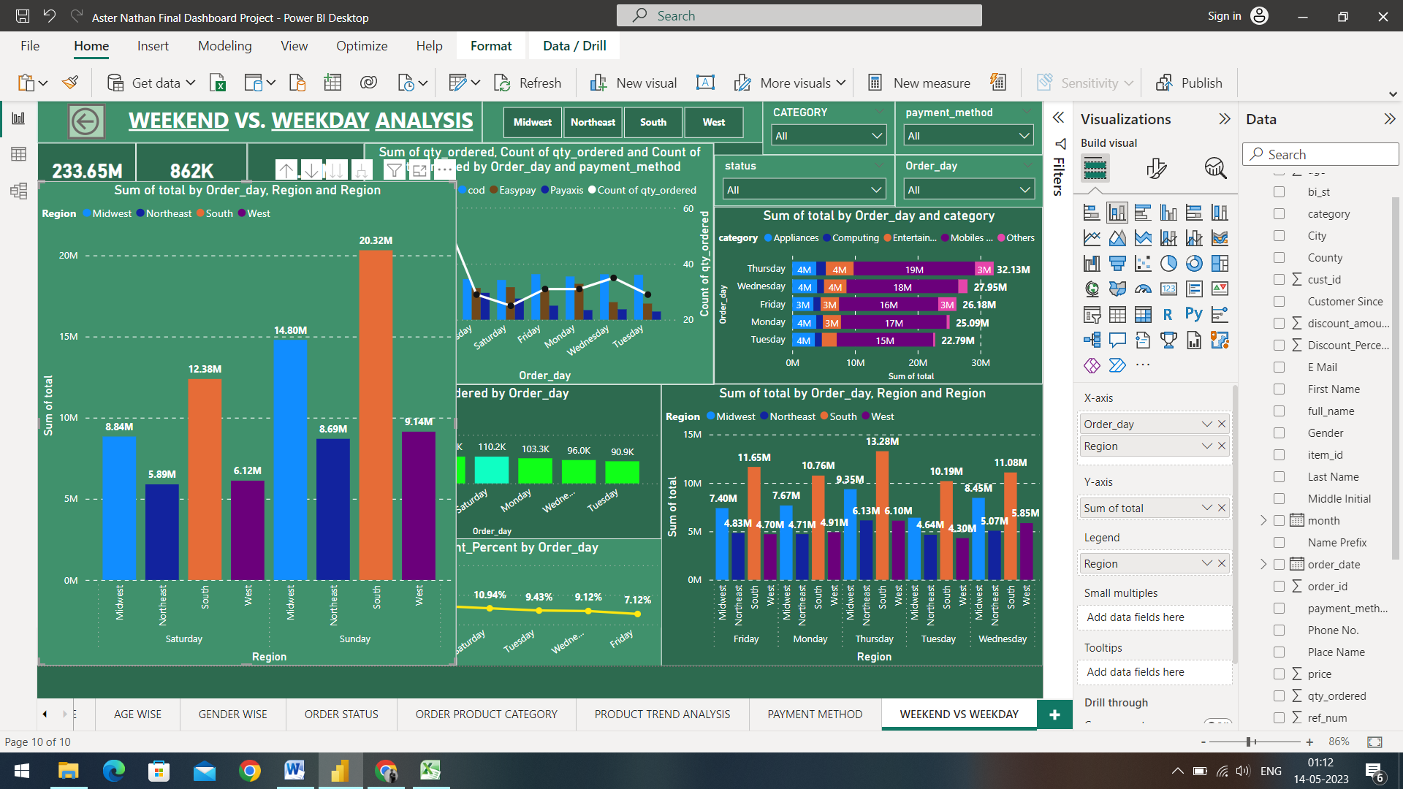

The above chart gives us an insight on the Weekend Analysis divided into Saturday and Sunday based on different regions.

* The customers trend on Saturdays’ in the South region generated 12.38M total sales, the Midwest region drove 8.84M total sales, followed by the West region with 6.12 M total sales and the Northeast region with 5.89M total sales.
* The customers trend on Sundays’ in the South region generated 20.32M total sales, the Midwest region drove 14.80M total sales, followed by the West region with 9.14 M total sales and the Northeast region with 8.69M total sales.

Key Driving Factors:

There are several key driving factors that can influence higher sales during weekends. Weekends are typically when people have more free time to shop and browse online. This means that businesses can expect more website traffic, higher engagement on social media, and increased sales during these times. Several businesses offer special deals and promotions during weekends, such as weekend sales or limited-time discounts.

1. Weekday Analysis by sum of total and Region:

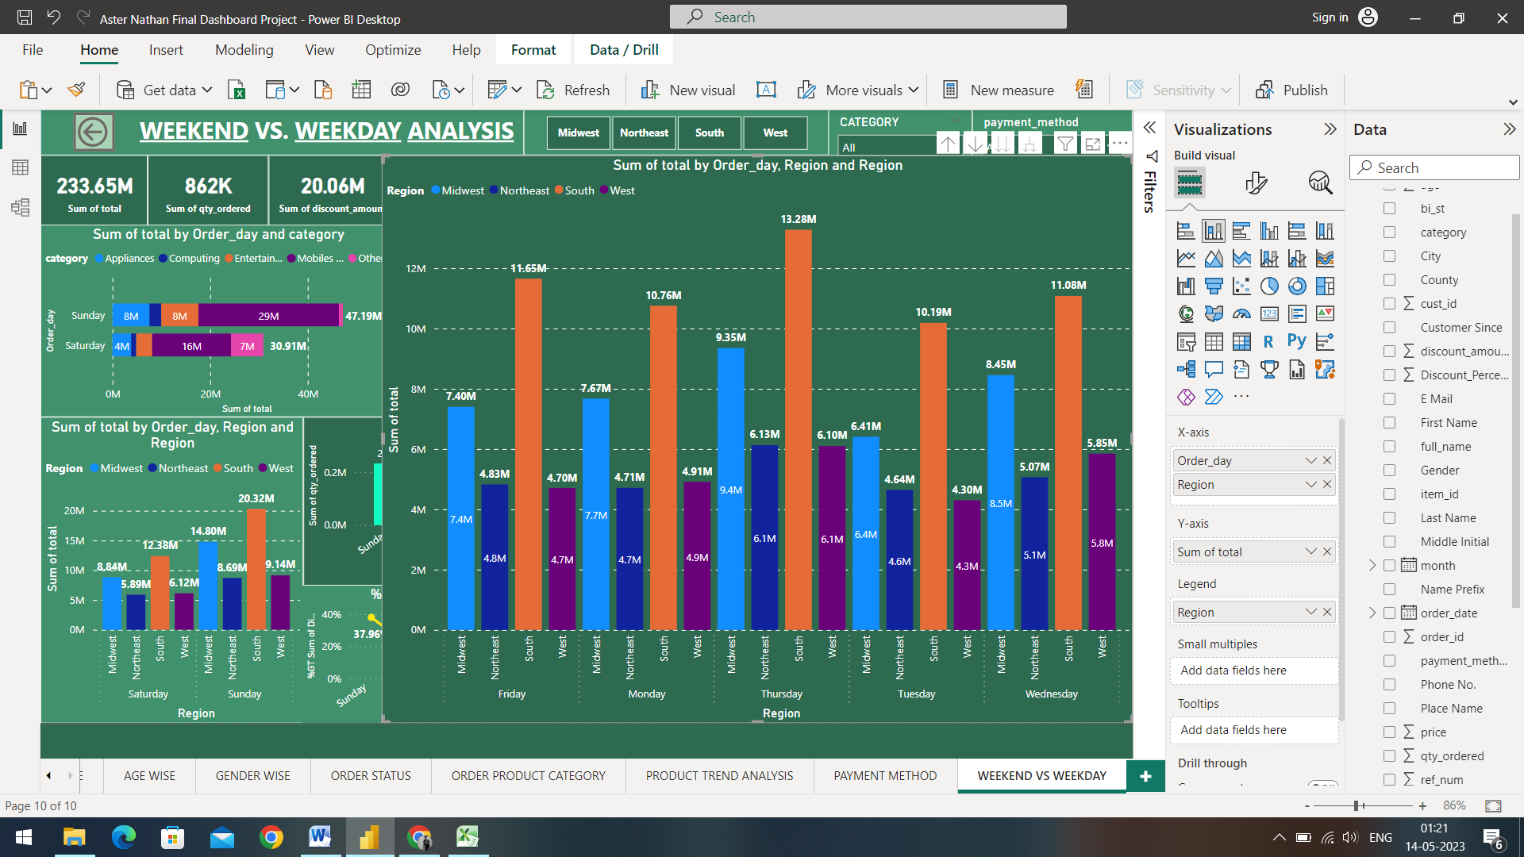

The above chart gives us an insight on the Weekday Analysis based on different regions.

* The customers trend on Fridays’ in the South region generated 11.65M total sales, the Midwest region drove 7.40M total sales, followed by the Northeast region with 4.83 M total sales and the West region with 4.70M total sales.
* The customers trend on Mondays’ in the South region generated 10.76M total sales, the Midwest region drove 7.67M total sales, followed by the West region with 4.91 M total sales and the Northeast region with 4.71M total sales.
* The customers trend on Thursdays’ in the South region generated 13.28M total sales, the Midwest region drove 9.35M total sales, followed by the Northeast region with 6.13 M total sales and the West region with 6.10M total sales.
* The customers trend on Tuesdays’ in the South region generated 10.19M total sales, the Midwest region drove 6.41M total sales, followed by the Northeast region with 4.64 M total sales and the West region with 4.30M total sales.
* The customers trend on Wednesdays’ in the South region generated 11.08M total sales, the Midwest region drove 8.45M total sales, followed by the West region with 5.85 M total sales and the Northeast region with 5.07M total sales.

Root Cause Analysis:

According to the chart and analysis above, we can see that several weekdays are performing and generating very low sales as compared to weekdays, this could be due to the competing priorities that customer have, such as work, school, or family obligations. This can make it more difficult for businesses to capture their attention and encourage them to make purchases. Business can offer convenient options for customers during weekdays, such as extended customer service hours or faster shipping, this can encourage customers from making purchases during this time.

1. Percentage of discount amount by days of the week

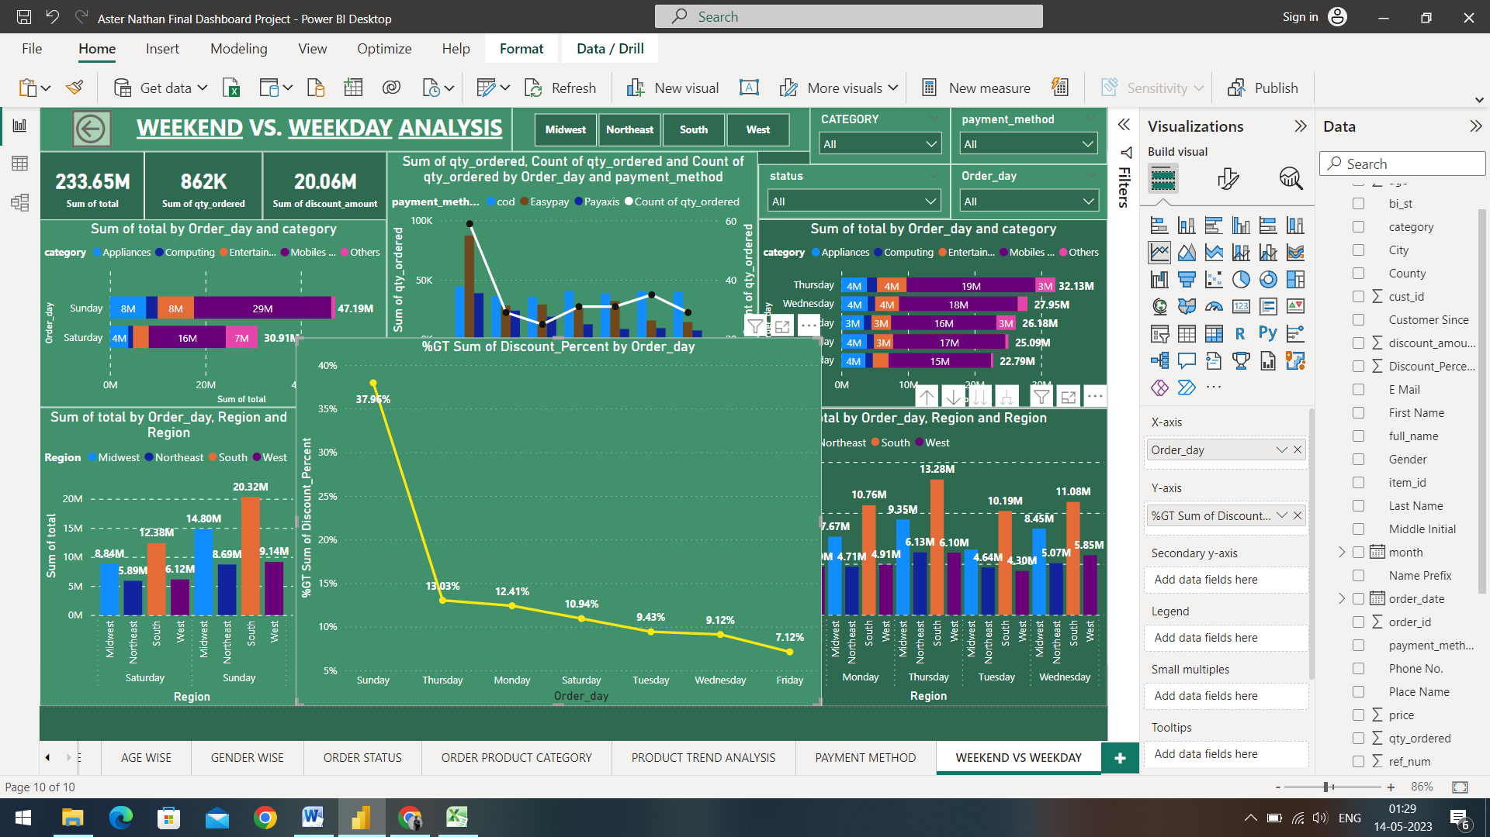

The visualization gives us an insight on the total percentage of discount given on specific days of the week

* The day of Sunday was given the most amount of Discounts compared to the other days with 37.96% of discount amount
* The day of Thursday was given the second most amount of Discounts with 13.03% of discount amount
* Third is the day of Monday that was given the total discount amount of 12.41%
* Followed by Monday, is Saturday were the discount amount given was 10.94%
* The day of Tuesday was given the discount of 9.43%
* Wednesday was given the discount of 9.12%
* The discount percentage dropped down to 7.12% as Friday was the day with the least amount of discount given

Key Driving Factors:

Discounts are often interrelated with higher sales because they can create a sense of urgency and motivate customers to make purchases. Discounts can attract new customers who may have been hesitant to make a purchase at full price. Discounts can also help businesses build customer loyalty by offering promotions and deals to existing customers. Time-sensitive discounts can create a sense of urgency for customers, encouraging them to make a purchase before the deal expires.